↓ Scroll Down ↓
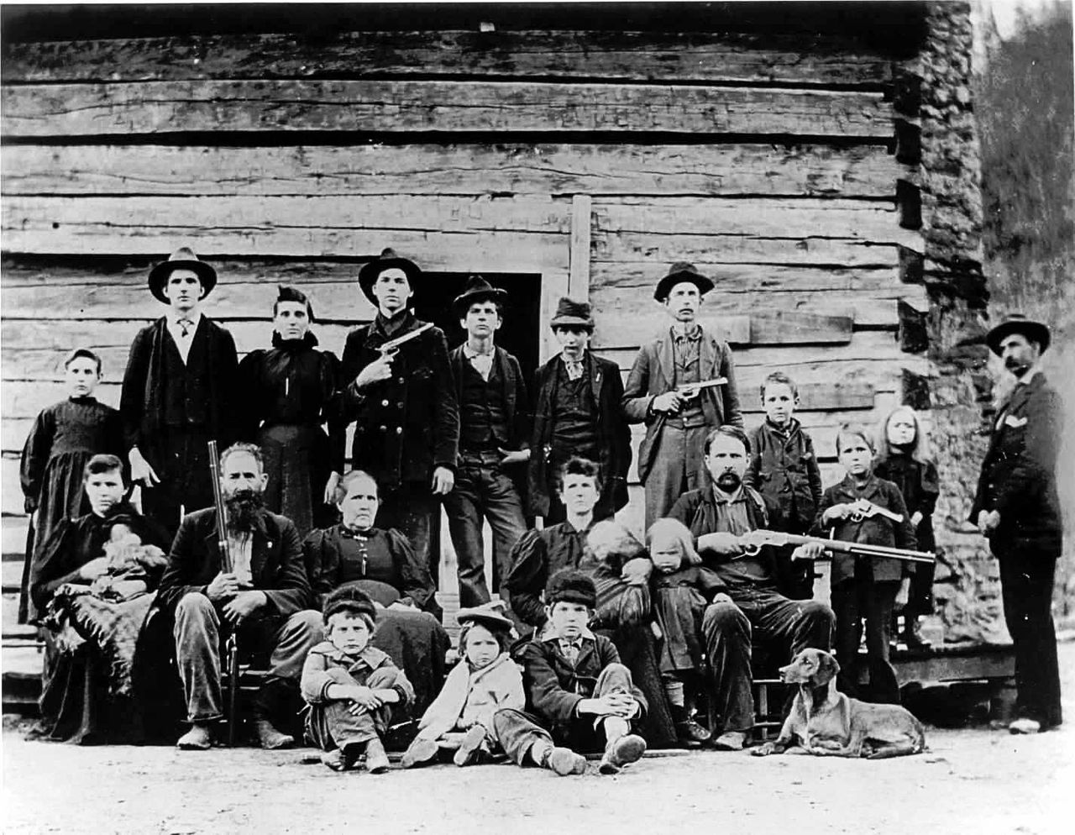
“BASKET OF DEPLORABLES” – EXHIBIT A

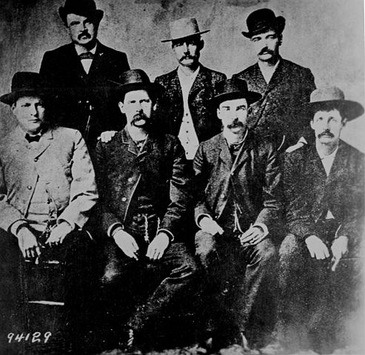
“BASKET OF DEPLORABLES” – EXHIBIT B
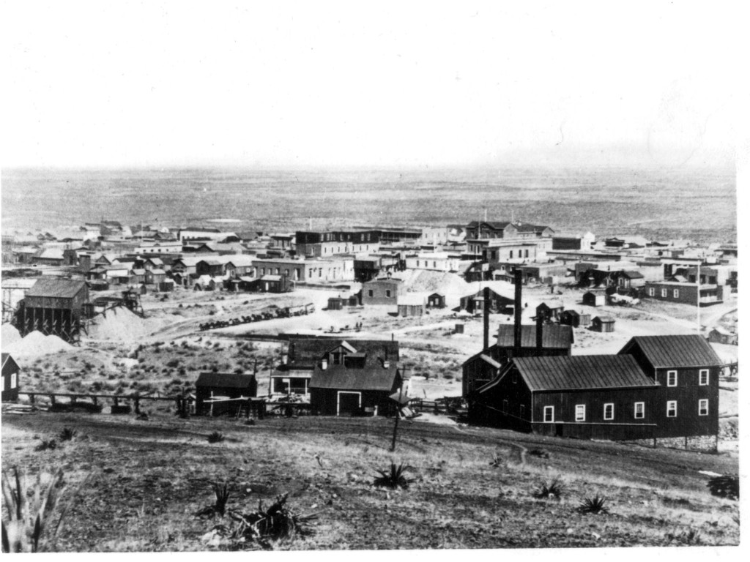
“CLING TO GUNS & RELIGION” “BASKET OF DEPLORABLES” RED FLYOVER STATE
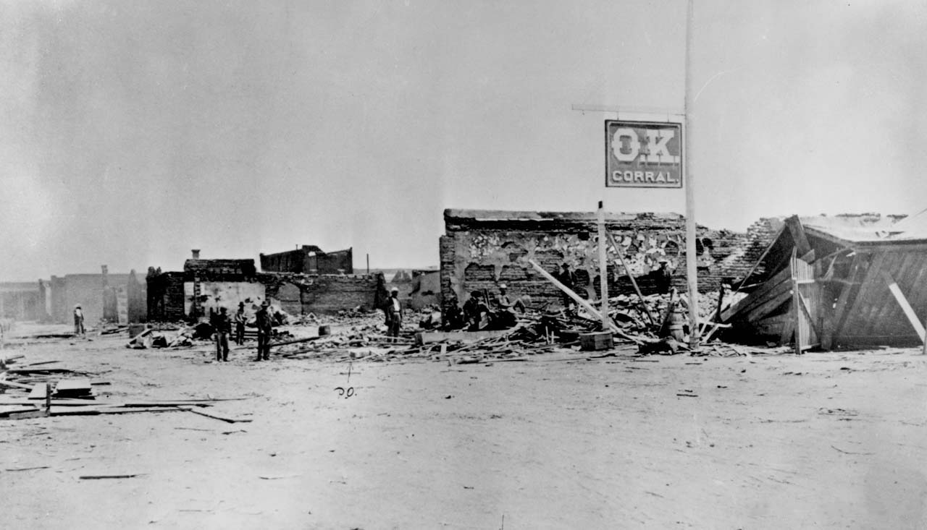
2017 RED STATE “BASKET OF DEPLORABLES”
NEW WORLD ORDER
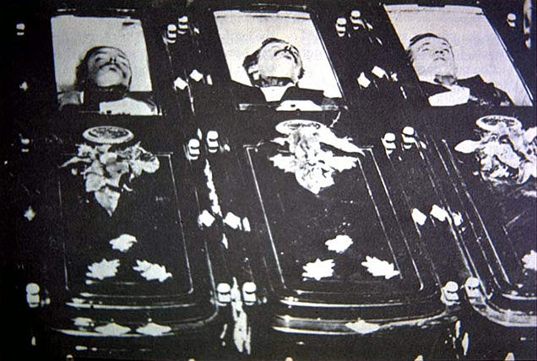

NOVEMBER 8, 2016
YOU WIN SOME
YOU LOSE SOME
↓ Scroll Down ↓


SIBERIAN SAMOYED – ORIGINAL DOG BREED; GENETICALLY CLOSEST TO WOLF; TOO FRIENDLY TO BE A GUARD DOG

↓ Scroll Down ↓
↓ Scroll Down ↓
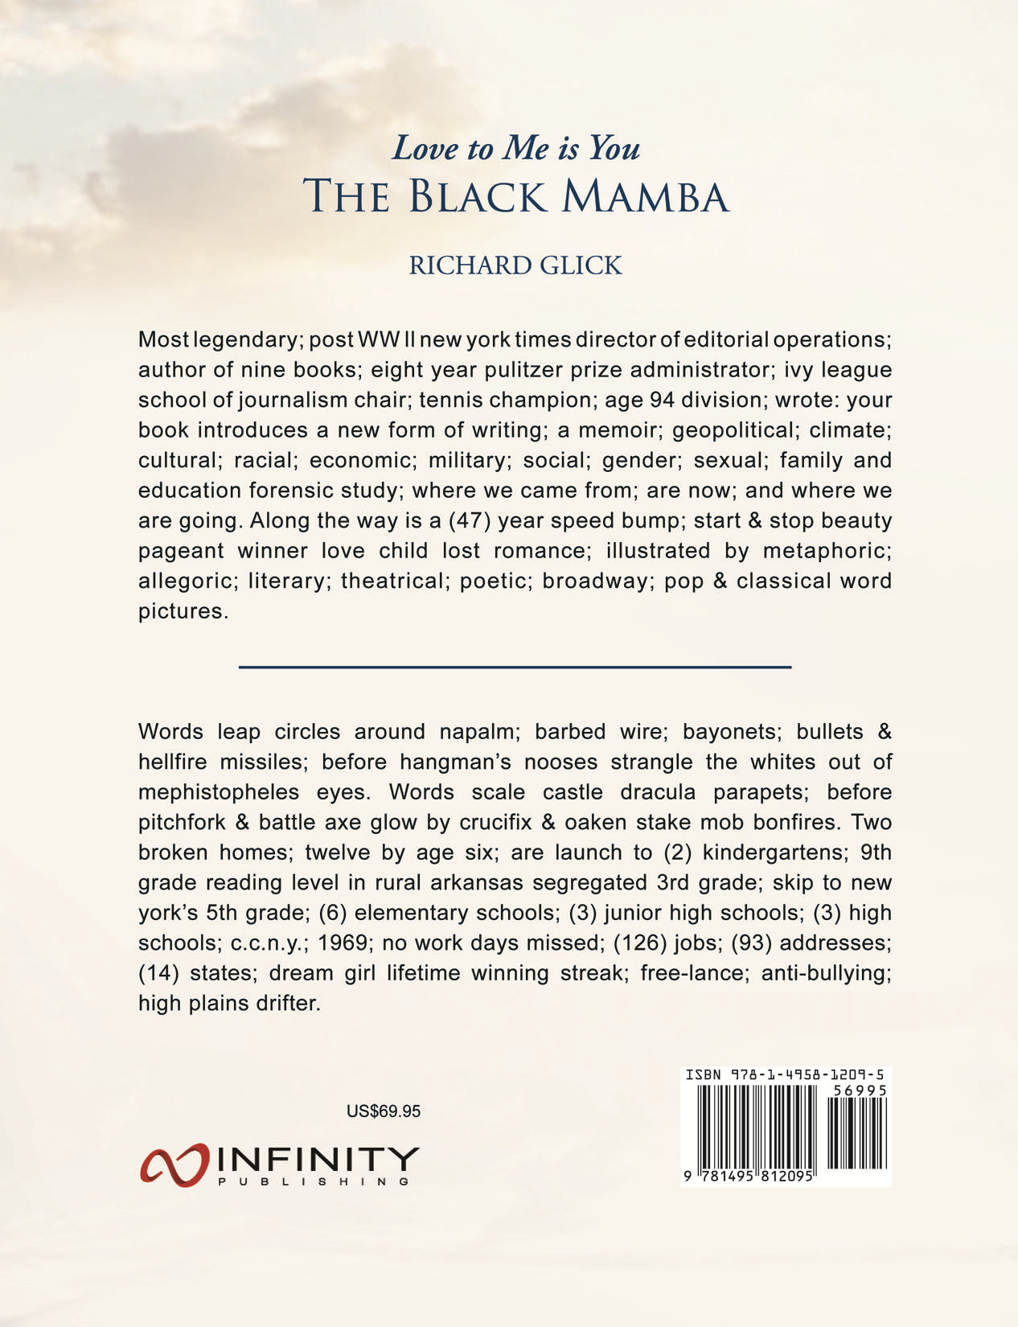
↓ Scroll Down ↓
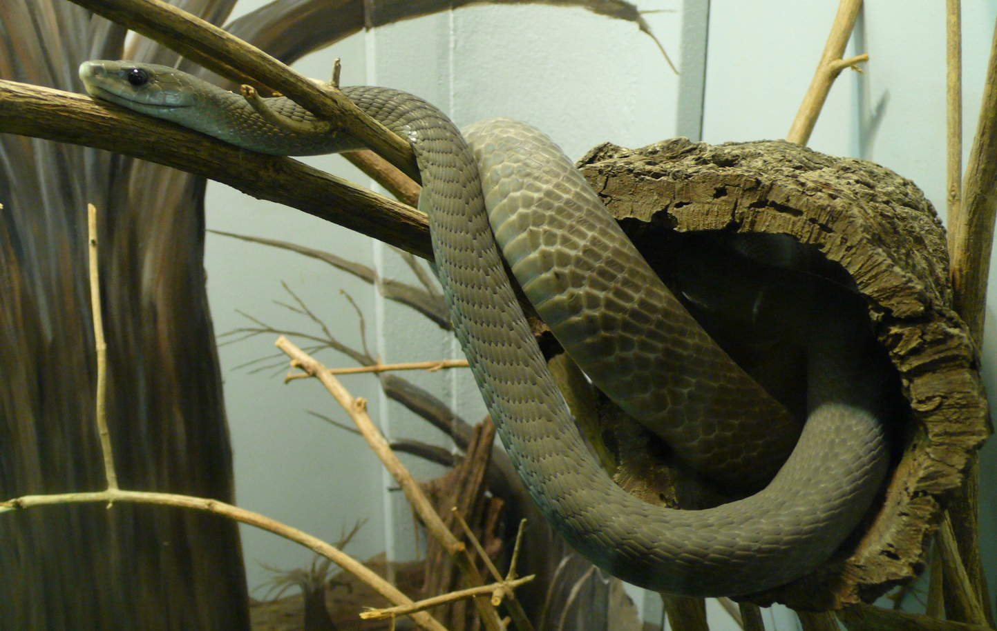
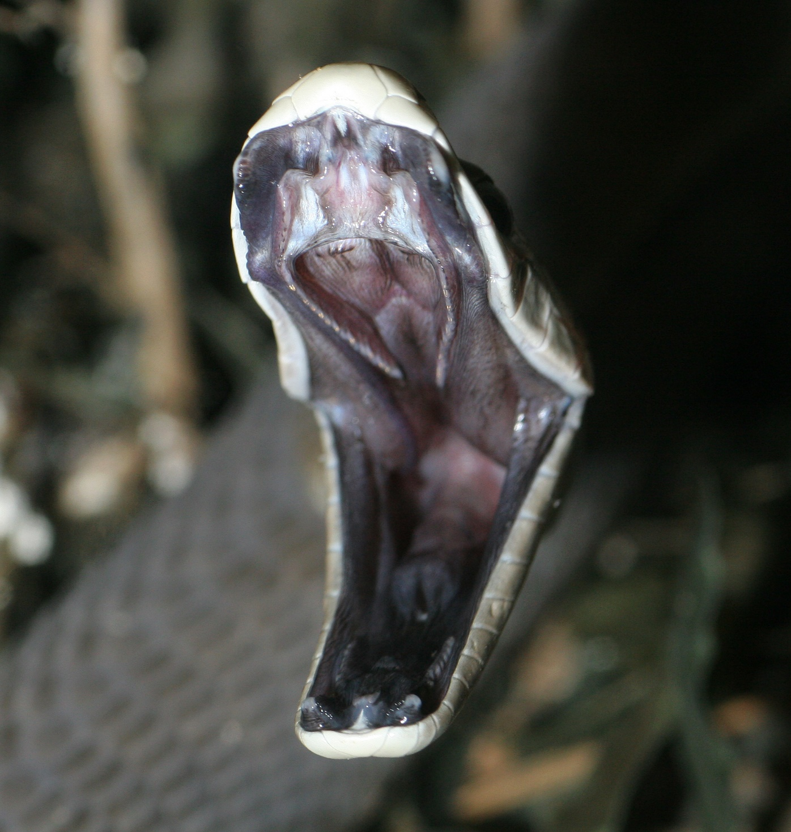

BLACK MAMBA – SUB-SAHARAN AFRICAN DEADLIEST OF 600 VENOMOUS SNAKES; KILLS IN 30 MINUTES; 14 FEET LONG; HIGHLY TERRITORIAL & AGGRESSIVE; STRIKES UNPROVOKED; SPEED 12 MPH; BITES HEAD & TORSO TEN TIMES IN ONE ATTACK; VENOM FROM ONE BITE CAN KILL TEN HUMANS.

↓ Scroll Down ↓
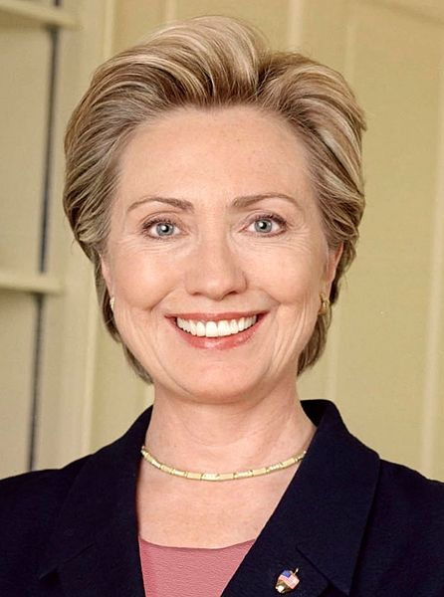
↓ Scroll Down ↓
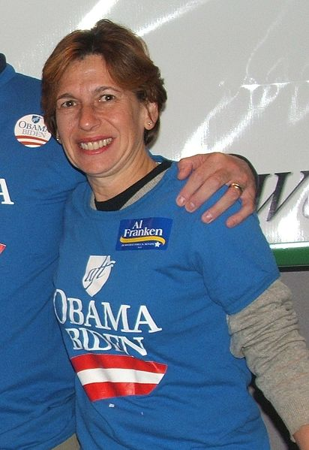
RANDI WEINGARTEN
JULY 11, 2015
$1,000,000,000
8,000,000
PANZER FRIENDS & FAMILY
NON-AGGRESSION
PACT
↓ Scroll Down ↓
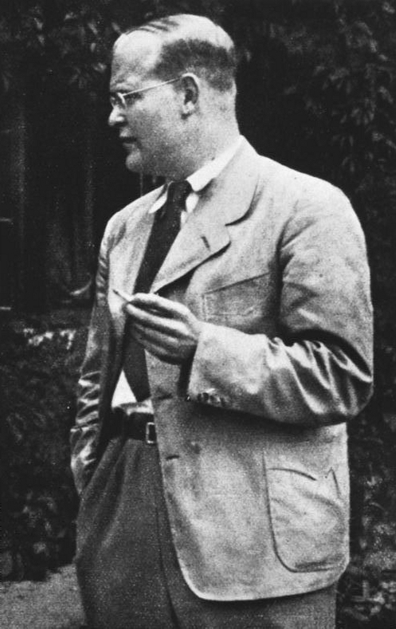 Messiah, Prophet or Saint?
4 February 1906 – 9 April 1945
DIETRICH BONHOEFFER
↓ Scroll Down ↓
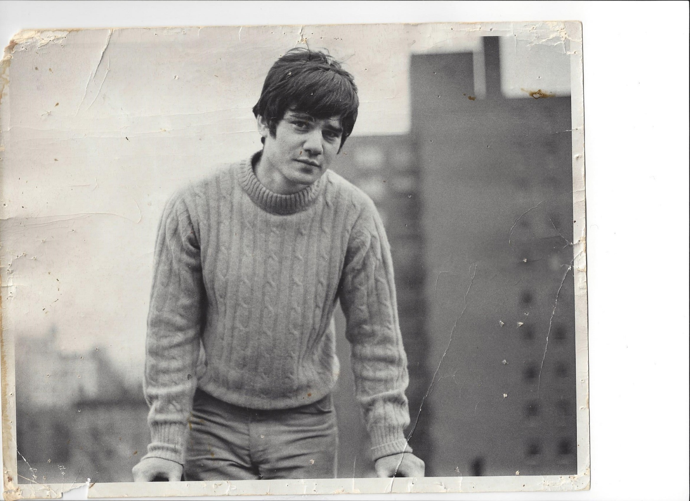
↓ Scroll Down ↓


↓ Scroll Down ↓

“An Eye for an Eye”
“A Tooth for a Tooth”
“Let a Thousand Vampires Bleed”
“In our Crime Scene World”
“Of Better Days Gone By”
“Hiroshima, Mon Amour”
“Is Hammurabi’s Code”
↓ Scroll Down ↓
Go to Amazon:
Love to Me is You: The Black Mamba
by Richard E. Glick
Link: http://a.co/06Evp0V
Barnes and Noble:
Love to Me is You: The Black Mamba
by Richard E. Glick
Link: http://fw.to/ydMsNoB
To buy this Book
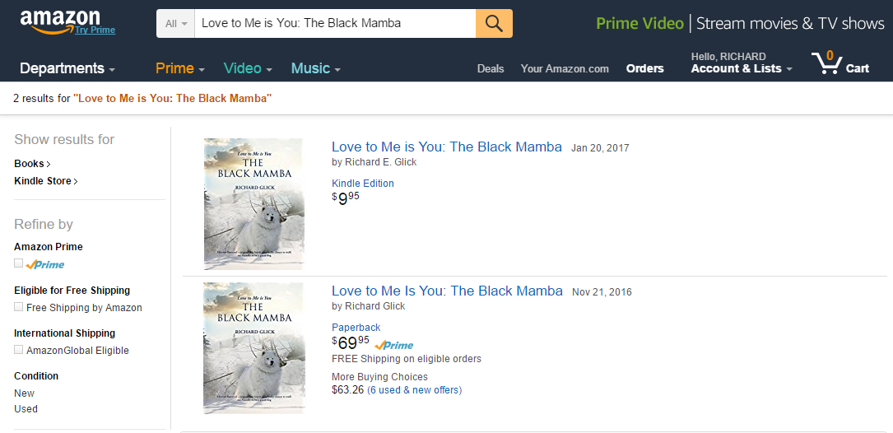

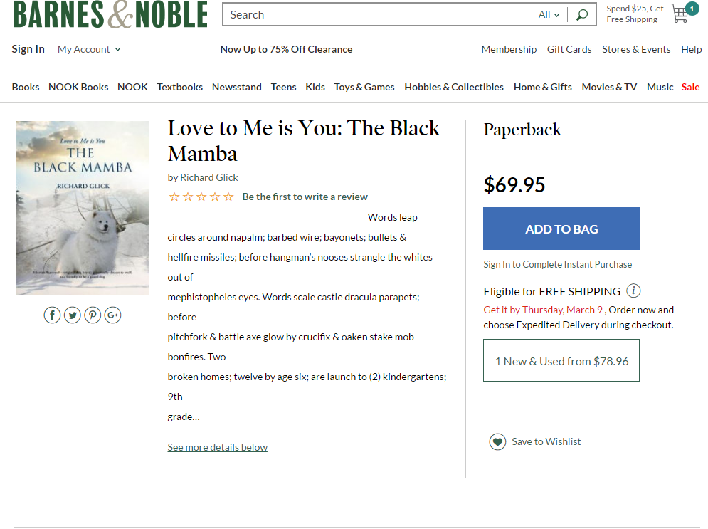

READ THE LIVING AUTOPSY OF THE “LENI RIEFENSTAHL” “TRIUMPH OF WILL” UNITED STATES EDUCATION INDUSTRIAL COMPLEX JOBS CARTEL.

RANDI WEINGARTEN IS THE MOST POWERFUL UNION LEADER IN THE WORLD; ONE OF FOURTEEN “READY FOR HILLARY” SUPER PAC PRIORITIES USA ACTION BOARD MEMBERS; BRINGING IN $192,052,125;
$7 MILLION FROM GEORGE SOROS; OF $1.4 BILLION TOTAL HILLARY 2016 FUNDING.
LIKE LOVE & MARRIAGE GOING TOGETHER WITH A HORSE & CARRIAGE, JULY 11, 2015 HILLARY RODHAM CLINTON ACCEPTED THE ENDORSEMENT OF THE (AFT) AMERICAN FEDERATION OF TEACHERS UNION PRESIDENT, RANDI WEINGARTEN.

THE CLINTON FOUNDATION & PRIORITIES USA ACTION IS THE RICHEST ONE-TWO PUNCH TO EVER EXIST.

THE DEMOCRATIC E=MC2 IS RANDI WEINGARTEN; UNLIMITED MONEY, AND THE EIGHT MILLION TEACHERS, FRIENDS & FAMILY SOLID VOTER BLOC.

SOON, THERE WILL BE NO BLACK MAMBA
THE TRACK RECORD OF THE NON-UNION EVA MOSKOWITZ (35) SCHOOL (11,000) STUDENT NEW YORK CITY CHARTER SCHOOL SUCCESS ACADEMY; IS FIVE YEARS OF STATISTICALLY DOUBLING THE STANDARDIZED MATH & VERBAL TEST SCORES OF RANDI WEINGARTEN’S LIKE DEMOGRAPHIC NEW YORK CITY AMERICAN FEDERATION OF TEACHERS UNION SCHOOLS.

UNION TEACHERS; DISGRACED BY NEW YORK STATEWIDE STANDARDIZED TEST SCORES; HIDE BEHIND “LEARNING STYLES;” AND STANDARDIZED TEST “OPT OUTS.” PARENT TEACHER COMMON CAUSE; IS ACADEMIC CHURCH OF THE LEFT VACCINE “OPT OUT” REINVENTION OF COMMON SENSE. THE MATH IS TEN BURIALS; IN CALIFORNIA IN 2010 OF WHOOPING COUGH TODDLERS. HALLOWEEN IS REAL LIVE RUBELLA; TETANUS; POLIO, MEASLES; HEPATITIS A & DIPHTHERIA KIDS WHO AREN’T ALIVE ANYMORE.

IN BLUE UNIFORMS; WITH HANDS UP; COMPETING FOR THE SUCCESS ACADEMY TEACHER’S ATTENTION; ARE (2688) WINNERS OF (22,000) SLOTS; 72% BLACK SINGLE PARENT & HISPANIC; EVA MOSKOWITZ SUCCESS ACADEMY LOTTERY APPLICANTS. THREE MILLION GHETTO KIDS ATTEND (7000) UNITED STATES; 72% GOVERNMENT FUNDED CHARTER SCHOOLS, NATIONWIDE. THE BALANCE OF CHARTER SCHOOL FUNDING IS PAID FOR BY PRIVATE PHILANTHROPY. “NO CHILD LEFT BEHIND;” IS EACH OF TWO MILLION CHILDREN LEFT BEHIND ON CHARTER SCHOOL WAITING LISTS.

LYNDON BAINES JOHNSON’S JANUARY 8, 1964 “GREAT SOCIETY” $22 TRILLION DECLARATION OF “THE WAR ON POVERTY;” NOW INCLUDES (288) DIFFERENT ANTI-POVERTY PROGRAMS. $22 TRILLION IS THREE TIMES THE COST OF EVERY WAR IN AMERICAN HISTORY COMBINED, FROM THE OPENING REVOLUTIONARY WAR APRIL 19, 1775; BATTLES OF LEXINGTON & CONCORD, THROUGH SYRIA, IRAQ & AFGHANISTAN TODAY.

“RACE IN AMERICA” IS FIVE COPS; JULY 8, 2016; & JOHN FITZGERALD KENNEDY; NOVEMBER 22, 1963; A FEW SHORT BLOCKS IN DALLAS; AND (52) YEARS & (229) DAYS APART.

THE “WAR ON POVERTY” BEGAN WITH LYNDON BAINES JOHNSON’S JANUARY 8, 1964 STATE OF THE UNION MESSAGE.

“OUR AIM IS TO NOT ONLY RELIEVE THE SYMPTOM OF POVERTY, BUT TO CURE IT, AND TO ABOVE ALL, PREVENT IT.”

THE “MANHATTAN PROJECT” BEGAN, OCTOBER 29, 1942, WITH THE EMINENT DOMAIN CONDEMNATION; BY THE U.S ARMY CORPS OF ENGINEERS; OF 56,000 ACRES IN OAK RIDGE, TENNESSEE.

IN 2006, IN OTHER DAYS OF A LITTLE “MANHATTAN PROJECT;” (165) “SPANKY & OUR GANG” “STYMIE” “LITTLE RASCALS;” BEGAN THE HARLEM SUCCESS ACADEMY’S “OPERATION OVERLORD;” ON THE 34 WEST 118TH STREET WRONG SIDE OF THE TRACKS.

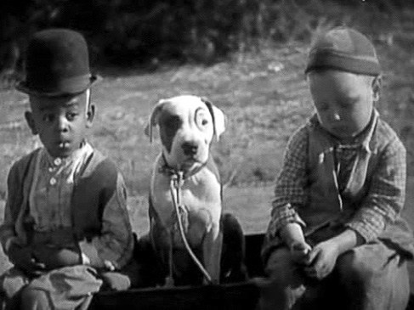

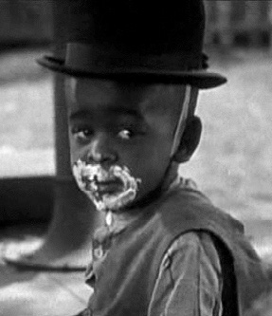

NO NEW SUCCESS ACADEMY CHARTER SCHOOL STUDENTS ARE ACCEPTED AFTER THE 4TH GRADE. SADLY, BY THEN, EVA MOSKOWITZ SAYS, UNIONIZED PUBLIC SCHOOL KIDS ARE TOO FAR BEHIND TO CATCH UP.

EDUCATIONAL INDUSTRIAL COMPLEX & POVERTY INDUSTRIAL COMPLEX “RACE IN AMERICA” IS “PROGRESSIVE” IDEOLOGUES WHO NEVER CHANGE THEIR MINDS, AND NEVER CHANGE THEIR SUBJECTS.

“RACE IN AMERICA” IS THE SELF-IMAGE MORAL CONCEIT OF BARACK HUSSEIN OBAMA; GROVELLING FOR TEACHERS UNION VOTES; WHO SINGLE-HANDEDLY; ON FEBRUARY 12, 2016; GUTTED THE (5000) STUDENT MIRACULOUS WASHINGTON D.C. “OPPORTUNITY SCHOLARSHIP PROGRAM;” BY CUTTING ITS FUNDING FROM $23 MILLION TO ZERO. BARACK HUSSEIN OBAMA REFUSED TO MEET WITH OVER 95% PLEADING LOW INCOME BLACK “WASHINGTON, D.C; OPPORTUNITY SCHOLARSHIP PROGRAM” KIDS’ PARENTS; INCLUDING MANY BLACK SINGLE PARENT MOMS. GOOGLE THE LEAD EDITORIAL OF THE FEBRUARY 13, 2016 WALL STREET JOURNAL.

JEREMIAH WRIGHT; & “BLACK LIVES MATTER;” “ALL FOR THE KIDS” IS CRONY $119K UNION TEACHER JOBS; GOLD-PLATED LIFETIME FAMILY HEALTH INSURANCE & AGE (55); (25) YEARS & OUT; $110K PENSIONS.

NOW YOU KNOW WHY YOUR PROPERTY TAXES ARE SO HIGH.
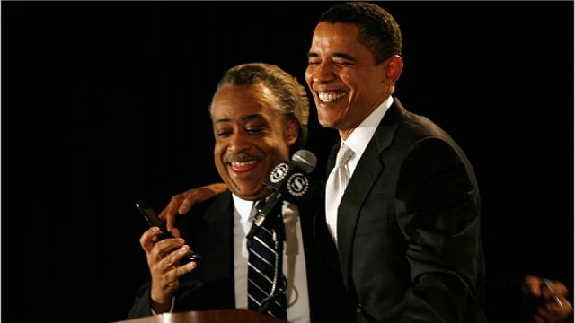

“RACE IN AMERICA” IS (72) OVAL OFFICE VISITS (NEWSMAX WaPo FACT CHECKER) FOR $4.5 MILLION INTERNAL REVENUE SERVICE TAX CHEAT AL SHARPTON; MADE SHAMEFUL BY BARACK HUSSEIN OBAMA’S DISINGENUOUS; WILLFUL IGNORANCE OF TAWANA BRAWLEY & FREDDIE’S FASHION MART.

AL SHARPTON IS BARACK HUSSEIN OBAMA’S FIDEL CASTRO & AYATOLLAH ALI KHAMENEI BOOKEND. GOOGLE AL SHARPTON’S 272 WEST 125TH STREET; HARLEM; DECEMBER 8, 1995 FREDDIE’S FASHION MART MASSACRE; SHARPTON BAITING ALLEGED “JEWISH INTERLOPER;” SOUTH BRONX PHILANTHROPIST JEW FRED HARARI; AND (7) INNOCENTS OF COLOR INCINERATED.

ADJOURN TO BARACK’S DECEMBER 27, 2016 GANG PRESSING U.N. ABSTENTION; PICKING UP WHERE THE 1903 RUSSIAN FORGERY “THE PROTOCOLS OF THE ELDERS OF ZION” MUTATED INTO SCORES OF TRANSLATIONS, WORLDWIDE, ABOUT THE JEWISH FILTH; HOOK-NOSED CONSPIRACY TO POISON THE WORLD. “THE PROTOCOLS OF THE ELDERS OF ZION” BECAME THE 1929 GRAND MUFTI OF JERUSALEM MASSACRE OF JEWS; STALIN’S POGROMS OF JEWS; AND THE SIX MILLION KRISTALLNACHT “JEWISH QUESTION.” “THE PROTOCOLS OF THE ELDERS OF ZION” IS TODAY FORGERY SYLLABUS TAUGHT AS FACT TO HUNDREDS OF MILLIONS OF MUSLIM CHILDREN WORLDWIDE; REPLICATING INTO SCORES OF GENOCIDAL ISLAMIC DOCUMENTARY TELEVISION SPIN-OFF SERIES.

SOVIET ARAB COMMON CAUSE WHORED THE 1975 UNITED NATIONS EDICT OF ZIONISM AS RACISM & RACIAL DISCRIMINATION. TENDER BARACK HUSSEIN OBAMA GRADE SCHOOL WAS IN THE ISLAMIC, JEW HATING INDONESIAN EPICENTER; LATER; MICHELLE; SASHA & MALIA JOINED HIM IN TOW TO JEW-HATER PREACHER JEREMIAH WRIGHT; UNDERGRADUATE COLUMBIA 1980’S PROFESSOR ANTI-SEMITE P.L.O. FRONT MAN EDWARD SAID; AND OBAMA’S JEW-HATING, HARD-LEFT CHICAGO COCKTAIL CABAL.

ISRAEL NEVER RELINQUISHED THE WEST BANK; EVICTED NO ARABS IN BUILDING HOMES FOR JEWS; AND WOULD BE DESTROYED IN LIEU OF BUFFER ZONES AGAINST A DEATH CULTURE DEDICATED TO JEWISH DEATH. BARACK FAVORS GOLF AT HIS ROYAL HAWAIIAN COUNTRY CLUB INSTEAD OF GOOGLING FREDDIE’S FASHION MART & TAWANA BRAWLEY. HIS PARTING SHOT IS MAKING THE UNITED NATIONS HIS SURROGATE AGAINST JEWISH “DEPLORABLES.”

SLICED & DICED ON THE BATTLEFIELD & BY MOSSAD; OBAMA’S INTERNATIONAL CHURCH OF THE LEFT GANG PRESSES THE U.N. FOR ANTI-SEMITE FIRST DOWNS AND ISRAELI ISOLATION; BOYCOTTS & DIVESTITURE. CLEARLY ANTI-SEMITIC; WHY SHOULDN’T THE INTERNATIONAL LEFT FLOAT LIKE A BUTTERFLY; AND STING THE ISRAELI ECONOMY LIKE A BLACK MAMBA; SILENT AS SIX YEAR OLD MUSLIMS STAB (80) YEAR OLD SLEEPING JEWISH WIDOWS AND INFANTS? LAST CALL FOR ALCOHOL IS SIX YEAR OLD GIRLS IDENTIFYING AS HULK HOGAN IN BOYS’ LAVATORIES; THE A.C.L.U. HACKING COURTHOUSE BACK DOORS; AND WILLFUL IGNORANCE OF THE 93% CHICAGO; BLACK-ON-BLACK 2014; 2015 & 2016; (416); (478) TO (762); MERRY-GO-ROUND OF HEARSES; EXCEEDING L.A. & NYC COMBINED.

RAMSES WITH A WINK; 2017:

“THE JEWS DID THIS TO US.”

JUST WHEN WE THOUGHT HE’D CLINCHED THE WORST PRESIDENCY POSSIBLE; PAST; PRESENT OR FUTURE; HE OUTDOES HIMSELF. WE HAVE (59) “GITMO” REMAINING DETAINEES; TOO LETHAL TO BE RELEASED; BLESSED BY HIS BEND-OVER-BACKWARDS-BENEFIT-OF-A- DOUBT. JANUARY 4, 2017, HE ANNOUNCED LETTING (19) MORE “GITMO” CHARLES MANSONS WALK BY JANUARY 20. DONALD J. TRUMP: “THESE ARE EXTREMELY DANGEROUS PEOPLE, WHO SHOULDN’T BE ALLOWED BACK ON THE BATTLEFIELD.” (19) MORE “GITMO” “JUNIOR VARSITY” CALIPHATE OF IRAQ & AL-SHAM GENIES TOTAL (119) OUT OF OBAMA’S BOTTLE.

“2016;” BY DINESH D’SOUZA; TIES BARACK HUSSEIN OBAMA SR.’S “THE ROOTS OF OBAMA’S RAGE” TO HIS SON; BARACK HUSSEIN OBAMA JR.’S BOOK; “DREAMS OF MY FATHER.”

BARACK HUSSEIN OBAMA SR.’S SHANGRI-LA WAS PAYBACK TO BRITAIN & THE UNITED STATES FOR PLUNDERING INDIGENOUS RESOURCES & LABOR. OBAMA SR. PROSELYTIZED “THE GREATEST THREAT TO HUMANITY IS THE POWER OF THE UNITED STATES.” JOMO KENYATTA; “FATHER OF KENYA” BLACKLISTED THIS - - EXPELLED FROM HARVARD - - “HIGH MAINTENANCE” - - LOOSE CANNON RABBLE ROUSER - - FATHER WITH (4) MOTHERS - - (4) TIME EXPLODING IN FLAMES DAYTONA CRACK-UP ARTIST, FROM HIS GOVERNMENT.

4,650,000 BEST SELLER; “DREAMS OF MY FATHER” IS BARACK HUSSEIN OBAMA SR.’S DREAM COME TRUE; CHANNELING HIS SON; BARACK HUSSEIN OBAMA JR.; TO BECOME THE PRESIDENT OF THE UNITED STATES.

OBAMA’S BUZZER-BEATING THREE POINTER IS THE “GITMO” 2017 VALEDICTORIAN BECOMING THE U.S DEPARTMENT OF HOMELAND SECURITY WARDEN.

IT CAN’T HAPPEN HERE? IT JUST DID HAPPEN.

ON LIVE TV; ON A MARCH, 1961, SUNDAY EVENING;
CASTRO, CUBA & COMMUNISM” WAS THE MOST WATCHED AMERICAN TELEVISION DOCUMENTARY OF ALL TIME.

OVER 100 MILLION AMERICANS SAW (1000) CUBAN DISSIDENTS WITH THEIR BACKS TO A TRENCH. 200 MILLION AMERICAN EYES SAW BELT UPON BELT OF MACHINE GUN BULLETS EMPTIED FROM A 50 CALIBRE, REAR-FACING; TRUCK-MOUNTED; MACHINE GUN; AS DOES THE CALIPHATE OF IRAQ & AL-SHAM TODAY; INTO (1000) SOULS. THEY WERE COVERED UP; MANY STILL ALIVE; BY A BULLDOZER INTO THE TRENCH BEHIND THEM. IT WASN’T NECESSARY FOR US TO READ ABOUT THIS. 100 MILLION AMERICANS SAW THIS LIVE VIDEO FOOTAGE; DISTRIBUTED PROUDLY TO THE WORLD; BY THE MOST EVIL MAN WHO EVER LIVED.

THE ABOVE (1000) WERE AMONG (5600) MOWED DOWN BY FIDEL CASTRO’S MACHINE GUNS. COUNTLESS OTHERS WERE “TERMINATED BY CASTRO WITH PREJUDICE” EXTRAJUDICIALLY; AS BY IRANIAN VAJA SECURITY & ISRAELI MOSSAD WITHOUT BORDERS.

MR. OBAMA ENSHRINED HIS CASTRO/MARTIN BORMANN/ADOLF EICHMANN LEGEND NOVEMBER 25, 2016; DESCRIBING FIDEL CASTRO AS A “SINGULAR FIGURE; WHOSE ENORMOUS IMPACT WILL BE RECORDED & JUDGED BY HISTORY.”

I WROTE OF MR. OBAMA; IN A JULY, 2014; PUBLISHED; WIDELY READ; RANTLIFESTYLE.COM ARTICLE. “THIS MAN IS DANGEROUS. AROUND THE WORLD; WERE HE LUCKY; HE’D BE UNDER HOUSE ARREST.”

DEPRAVED INDIFFERENCE IS MEASURED BY 1 MILLION; INCLUDING 650,000 WOMEN & CHILDREN; SYRIAN HOLOCAUST DEAD. HE LECTURES BLACK AMERICA; “YOU’RE INSULTING MY LEGACY IF YOU DON’T TURN OUT IN FORCE TO ELECT HILLARY RODHAM CLINTON.” HE HAS SECRET SERVICE PROTECTION FOR LIFE. WHAT ABOUT HIS ISLAMIC STATE “JUNIOR VARSITY?”

WILL THE “SINGULAR” BARACK HUSSEIN OBAMA; WHO LET THE CALIPHATE OF IRAQ & AL SHAM GENIE OUT OF THE BOTTLE; BE JUDGED BY HIS DEPRAVED INDIFFERENCE FROM PORTALS OF DUST?

OBAMA’S TRIFECTA IS FLYING $1.3 BILLION IN EUROS & SWISS FRANCS TO TEHRAN; DEPRAVED INDIFFERENCE TO PUTIN’S IRANIAN SALE OF THE SAME SA 300 SURFACE-TO-AIR MISSILES THAT SHOT DOWN MALAYSIAN MH-17; JULY 17, 2014; OVER UKRAINE; AND BOEING’S $17 BILLION; (80) AIRCRAFT IRAN TERROR FRIENDLY SKIES DEAL. OBAMA TURNS OUR WORST ENEMIES LIKE FIDEL CASTRO & AYATOLLAH ALI KHAMENEI INTO HIS BEST FRIENDS; AND OUR BEST FRIENDS LIKE ISRAEL & TAIWAN INTO HIS WORST ENEMIES.

MARCH 22, 2016; BARACK HUSSEIN OBAMA SAT NEXT TO RAUL CASTRO IN HAVANA; ENJOYING THE TAMPA BAY RAYS BASEBALL GAME WITH CUBAN ALL-STARS. WHILE THE GAME WAS IN PROGRESS; THE CALIPHATE OF IRAQ & AL SHAM MURDERED (32) CIVILIANS & SHREDDED OVER (300) AT THE BRUSSELS AIRPORT & MAALBEEK METRO STATION. MR. OBAMA BLEW IT ALL OFF AS PROPORTIONATE TO “BATHTUB SLIPS.”

GOOGLE IT. MARCH 22, 2016.

GAG ON IT.

GOOGLE JOSE DANIEL FERRER GARCIA; LEADER OF THE CUBAN PATRIOTIC UNION & EIGHT YEAR INMATE OF CUBA’S PARALLEL MAXIMUM SECURITY “PRISION PROVINCIAL;” IN GUANTANAMO, CUBA; IN OUR OWN “GITMO” NEIGHBORHOOD.

MR. GARCIA DESCRIBED OUR “GITMO;” TO BRET STEPHENS OF THE WALL STREET JOURNAL; AS A “JARDIN DE NINOS; A KINDERGARTEN;” COMPARED TO CASTRO’S BERGEN-BELSEN/AUSCHWITZ.

WHEN NOT SCHMOOZING WITH “REVEREND” AL SHARPTON AND HIS CASTRO BUTCHER BRETHREN; MR. OBAMA LIKENS PROFIT & LOSS CAPITALISM TO A DISEASE; WITH REGULATORY NOOSES & TRAP DOORS.

AMERICA NEVER UNDERSTOOD THE SINISTER, SYMMETRICAL COMMON DENOMINATOR OF BARACK HUSSEIN OBAMA’S NATIONAL SOCIALIST, AUTHORITARIAN; REGULATORY POLICE STATE. OBAMA GOVERNED BY BULLYING REGULATORY DECREE, NOT LAW. HARVARD LAW SCHOOL’S LAURENCE H. TRIBE; AMERICA’S PREEMINENT CONSTITUTIONAL LAW THEORIST & SCHOLAR; EXPLAINS THAT EVERY U.S. LAW MUST PASS RIGOROUS CONSTITUTIONAL MUSTER, AND MUST BE ENACTED EITHER BY A FEDERAL OR STATE LEGISLATURE. IN THE ROTTEN-TO-THE-CORE OBAMA AUTHORITARIAN POLICE STATE; REGULATIONS ARE IMPOSED BY DECREE BY UNELECTED ACTORS; ARBITRARILY & CAPRICIOUSLY. REGULATORS SEIZE TRILLIONS OF DOLLARS IN PROPERTY & IMPOSE FINES & IMPRISONMENT. REGULATIONS CAN BE UNCONSTITUTIONAL IN SPIRIT; REGULATIONS; AS OPPOSED TO LAWS; DO NOT HAVE TO MEET CONSTITUTIONAL MUSTER; AND CAN BE IMPOSED & ENFORCED WITH CONTEMPT FOR ACTUAL & IMPLIED CONSTITUTIONAL EQUAL PROTECTIONS.

GOOGLE IT.

RE: TRUMP “IT DEPENDS ON WHAT YOU MEAN BY AUTHORITARIAN.”

THE WALL STREET JOURNAL SEER WILLIAM McGURN., WROTE DECEMBER 16; 2016; THE U.S. COMPETITIVE INSTITUTE RECKONS THAT THE FEDERAL REGULATORY BUREAUCRATIC GESTAPO (MY ADDENDUM)) FROM BARACK HUSSEIN OBAMA ON DOWN, SANK (35) NEW INDIVIDUAL REGULATION (FANGS) INTO FREE ENTERPRISE CAPITALISM; FOR EVERY SINGLE LAW PASSED BY THE U.S. CONGRESS & STATE LEGISLATURES DURING HIS PRESIDENTIAL ADMINISTRATION. BARACK HUSSEIN OBAMA’S AMBIGUOUS DISINGENUITY COMMON DENOMINATOR BY DESIGN; IS OPPORTUNISTICALLY SUCKING INTO THE PUBLIC SECTOR EVERY POSSIBLE DOLLAR; WHILE EUTHANIZING PRIVATE SECTOR JOBS & MONEY-CHANGING-HANDS ECONOMIC ACTIVITY.

DEMOCRATS HAVE BECOME FRANTIC AS IT SINKS IN THAT THEY’VE LOST NOT JUST THE PRESIDENCY; BUT (6000) PRESIDENTIAL STAR CHAMBER APPOINTEES; AND HUNDREDS OF THOUSANDS OF PATRONAGE HACK JOBS CHERRY PICKED BY THESE CORE (6000) OBAMA PATRONAGE HACKS. YOU MUST MEET OBAMA’S IDEOLOGICAL LITMUS PSYCHOLOGY; TO GET PAST A FIRST SCREENING INTERVIEW. “PROGRESSIVE” MODUS OPERANDI IS MARIONETTE ANTI-CAPITALISM GDP SUBSUMED BY THE PUBLIC SECTOR, AND 2017 “CLIMATE” BEING WHAT SLAVERY WAS IN 1860. “PROGRESSIVE “MEIN KAMPF” IS TO “KEEP FOSSIL FUELS IN THE GROUND;” CODE HARD-LEFT “CLIMATE” ANTI-CAPITALISM IN A SHEEP’S CLOTHING.

UNSAID ABOUT TRUMP CLEANING HOUSE OF TREE HUGGERS; IS THAT THESE TENS OF THOUSANDS OF PARASITIC TOM STEYER ACADEMIC LEECH DISCIPLES HAVE NO OTHER EMPLOYMENT SKILLS OR OPTIONS BESIDES SELECTIVELY CHERRY PICKING “SCIENCE” TO SUBSTANTIATE THEIR SOLYNDRA EARTH WORSHIP. SHORT OF “PROGRESSIVE” CHERRY PICKING SUBSTANTIATION EARTH WORSHIP; THEIR DIRTY LITTLE OPTION IS POUNDING THE PAVEMENT, IN SEARCH OF A JOB.

(288) EZ QUALIFY SAFETY NETS ARE SWAPPED FOR DEMOCRATIC VOTES. HE ACTUALLY WAS PLANNING A NEW WEBSITE TO PROMOTE INCREASED SAFETY NET CONSUMPTION AT “PROGRESSIVE” ALL-YOU-CAN-EAT BUFFETS FOR VOTES. “PROGRESSIVES” FAVORITE WORD ABOUT US IS “MESS.” OUR PASSION AGAINST “PROGRESSIVE BULLYING DEPRAVED INDIFFERENCE” IS “ANGER.” “PROGRESSIVES” ALL-PURPOSE DISS OF US IS “BROKEN.”

CARPET LAP DOG RUSSIAN POODLE PHISHERS NICHOLAS KRISTOF & JOHN PODESTA MEET “PETEY;’ THE PIT BULL (GOOGLE) OF “SPANKY & OUR GANG;” AT
1-800-$125.UNWANTED.MUTT.WE.COME. TO YOU.COM; M/C, VISA & DISCOVER ACCEPTED.

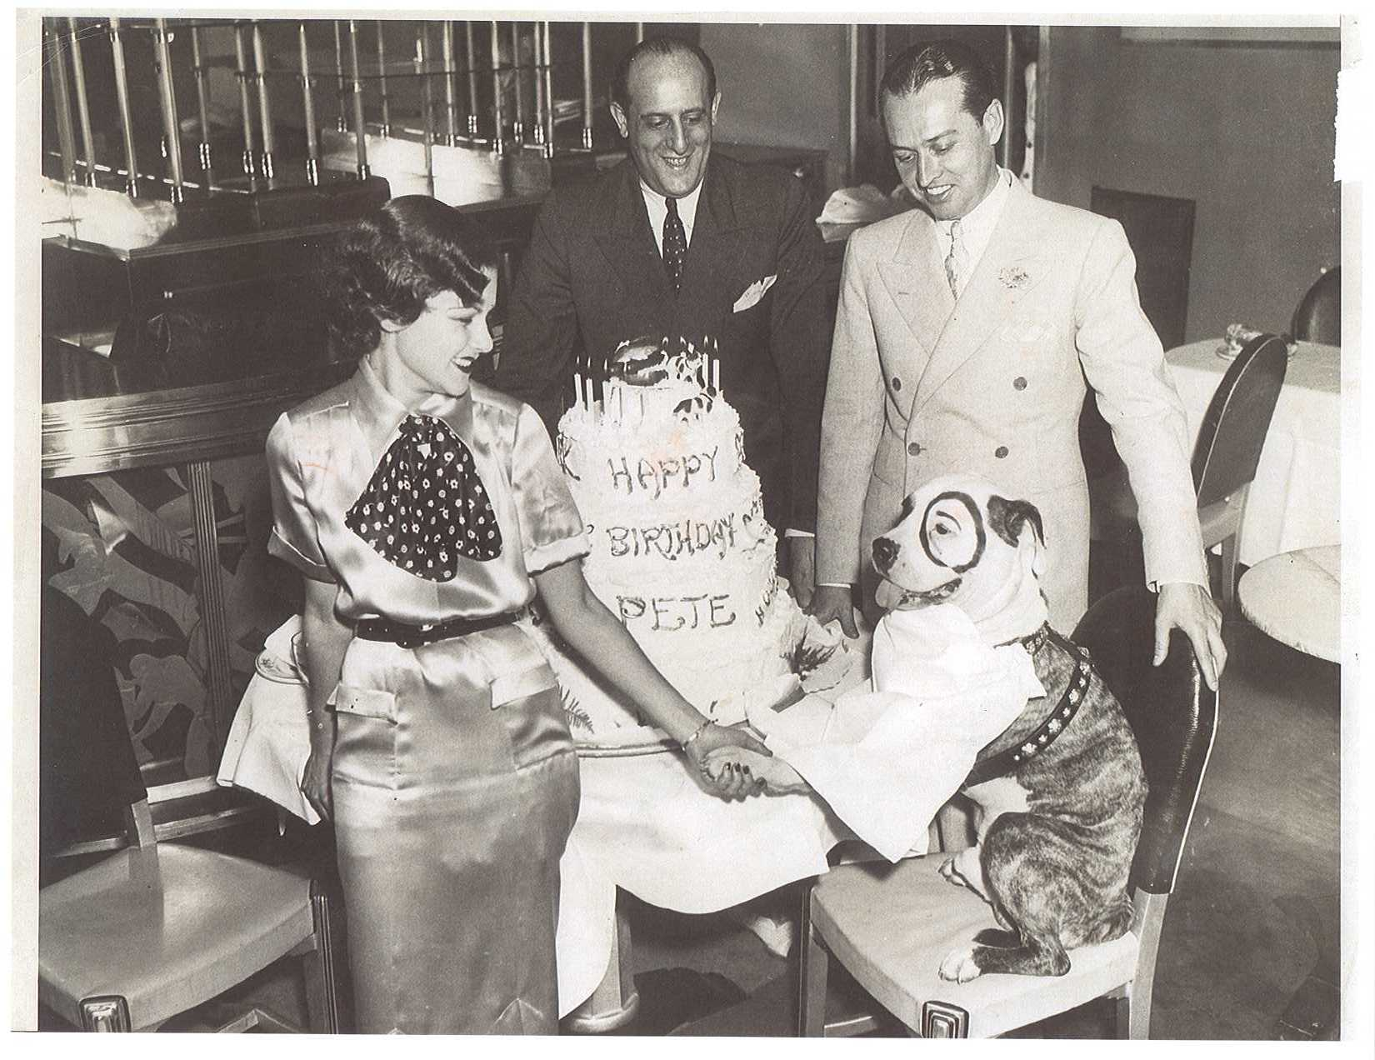

NEW YORK TIMES OP-ED NICHOLAS KRISTOF; 62,979,636 AMERICANS LAUGH IN YOUR FACE. YOUR 91% HILLARY MALPRACTICE WOULD BE GOOD FOR HENRY’S AXE IN THE TOWER. YOU’RE DIARRHEA COLUMNS PISS INTO CATEGORY FIVE WINDS. THE NEW YORK TIMES; DECEMBER 19, 2016; GROVELLED FOR STUDENTS & OBVIOUSLY, RANDI’S UNION
TEACHERS TO BUY YOUR DIARRHEA FOR (99) CENTS FOR (4) WEEKS. WHEN I GOT RID OF YOUR RAG FOR THE WALL STREET JOURNAL IN 2010; YOUR “SAVE TEAM” PLEADED WITH ME TO ACCEPT FREE DELIVERY OF THE TIMES.

BLOOMBERG: DECEMBER 19, 2016; JOHN PODESTA ELECTOR QUISLINGS MEET “BUFFY THE VAMPIRE SLAYER.” DONALD J. TRUMP; GOLDMAN SACHS & WARREN BUFFET GO BIG INTO FOUR COLOR SILK SCREEN TOMMY HILFIGER ELECTOR LICENSED OAK STAKE TEE SHIRT FUTURES.

I DROVE A NEW YORK CITY YELLOW MEDALLION CAB IN 2013; WHILE EDITORIAL OPINION WRITER FOR THE NYC TRANSPORTATION INDUSTRY TRADE NEWSPAPER; THE TAXI INSIDER.

I BROUGHT A HIGH LEVEL U.S. HOMELAND SECURITY EXECUTIVE TO THE ONE-TIME BROOKLYN NAVY YARD; NOW NYC COMMAND CENTRAL OF POSSIBLY THE LARGEST OF THE 240,000 EMPLOYEE HOMELAND SECURITY OUTPOSTS. THIS HEAD HONCHO TOLD ME HE’D BE FIRED IF I QUOTED HIM. HE ACTUALLY GAVE ME HIS CARD. TO KEEP HIM SAFE, I THREW IT AWAY.

- EVERY ONE OF HIS CO-WORKER HOMELAND SECURITY CRONIES IS AN EXTRAVAGANTLY PAID; INTIMATELY CONNECTED; POLITICAL PATRONAGE HACK; ADHERING TO THE HARD-LEFT BARACK HUSSEIN OBAMA AGENDA.

- U.S. HOMELAND SECURITY HAS CONTEMPT FOR THE U.S. TAXPAYER; REQUIRING ALL EMPLOYEES TO FLY FIRST CLASS; AND STAY ONLY AT FIVE STAR HOTELS.

- NEW HOMELAND SECURITY DIRECTOR; RETIRED U.S. MARINE; SOUTHERN COMMAND CHIEF; GENERAL JOHN F. KELLY; WILL GET JUSTICE FOR HIS SON; 2ND LT. ROBERT M. KELLY; KILLED IN AFGHANISTAN BY THE TALIBAN; WHILE OBAMA TIED THE U.S. MILITARY’S RIGHT ARM BEHIND ITS BACK. HOW ABOUT JUSTICE FOR LT. ROBERT M. KELLY; AND MULTIPLE SOLDIERS WHO WERE KILLED IN AFGHANISTAN WHILE SEARCHING FOR; AND TRYING TO RESCUE DESERTER BOWE BERGDAHL? DON’T BELIEVE THE NEWS AND DEFENSE DEPARTMENT DAMAGE CONTROL. IT HAPPENED. A CO-WORKER EDITOR WHO LED THE BERGDAHL RESCUE ATTEMPT; TOLD ME ABOUT HIS FRIENDS WHO DIED TRYING TO RESCUE BERGDAHL. BARACK HUSSEIN OBAMA EXCHANGED OUR FIVE WORST “GITMO” KILLERS FOR DESERTER BOWE BERGDAHL. OBAMA’S “CODE PINK;” WAS HONORING BOWE BERGDAHL IN THE WHITE HOUSE ROSE GARDEN; MAY 31, 2014, WITH BOWE BERGDAHL’S PARENTS, JANI & OBSERVANTLY BEARDED BOB.

- GOOGLE IT. MASTER OF CEREMONIES BOB BERGDAHL; IN THE WHITE HOUSE ROSE GARDEN; SHOULDER-TO-SHOULDER WITH BARACK HUSSEIN OBAMA JR:

- “BISM ALLAH ALRAHMAN ALRAHEEM” WHICH MEANS “IN THE NAME OF ALLAH THE MOST GRACIOUS AND MOST MERCIFUL.”

- BOWE BERGDAHL TODAY FACES U.S. ARMY DESERTION COURT MARTIAL CHARGES.

- GENERAL KELLY WILL DRAIN THIS HARD-LEFT 5TH COLUMN HOMELAND SECURITY BROOKLYN SWAMP; WHILE KICKING SAND INTO THE FACES OF EVERYONE WHO WANTS TO CLOSE “GITMO.” OBAMA PROCLAIMS “GUANTANAMO IS NOT WHO WE ARE.” IF TAKEN ALIVE BY ISRAELI MOSSAD OR IRANIAN VAJA SECURITY; U.S. “GITMO” GUESTS WOULDN’T HAVE LIVED LONG ENOUGH TO GET TO “GITMO.”

- GENERAL KELLY SAID: “GIVEN THE OPPORTUNITY; OUR SAVAGE ENEMY WOULD GLADLY LAUNCH ANOTHER 9/11 ATTACK.

- “I DON’T KNOW WHY THEY HATE US.”

- “QUITE FRANKLY; I DON’T REALLY CARE.”

- “THEY DO HATE US; AND ARE IRRATIONALLY DRIVEN TO OUR DESTRUCTION.”

ALL DENIERS OF AMERICAN
EXCEPTIONALISM ARE SMOKED OUT WITH THIS HANDY LITMUS TEST. WHEN A UNIVERSITY-LEFT INTELLIGENTSIA CLINICAL SPECIMEN IS CORNERED BY IRREFUTABLE LOGIC; HE WALKS AWAY; AND/OR SLAMS HIS FACE SHUT TO END THE CONVERSATION.

DAVID P. CARTER; IN HIS DECEMBER 1, 2016 LETTER TO THE WALL STREET JOURNAL; WROTE: WHEN CORNERED IN LOGIC AND/OR LOSING ELECTIONS; “PROGRESSIVE” LIBERALS HAVE NO USE FOR FACTS; REASON; LOGIC OR COMMON SENSE. HILLARY’S DISDAIN FOR FACTS COST HER THE ELECTION. DONALD TRUMP HAMMERED FACTS HOME. HE WON.

THE “BASKET OF DEPLORABLES” CLINGS TO ITS “GUNS & RELIGION.” DOES REDISTRIBUTION BEAT GROWTH? WE ARE RACIST; SEXIST; HOMOPHOBIC; XENOPHOBIC & ISLAMOPHOBIC; WITH DEEP SEATED CULTURAL CODES; RELIGIOUS BELIEFS & STRUCTURAL BIASES THAT PREDISPOSE US AGAINST THE “WOMAN’S HEALTH” OF CRUSHING THE SKULLS OF 3RD TRIMESTER VIABLE LIFE IN EXQUISITE PAIN.

DEPLORABLES ELECTED DONALD J. TRUMP; (52) REPUBLICAN VS. (48) DEMOCRATIC SENATORS; (241) REPUBLICAN VS. (194) DEMOCRATIC HOUSE CONGRESSMEN; (33) REPUBLICAN VS. (17) DEMOCRATIC STATE GOVERNORS. WE HAVE REPUBLICAN MAJORITIES IN (67) OF (98) STATE LEGISLATURES. WE HAVE REPUBLICAN MAJORITIES IN BOTH LEGISLATIVE CHAMBERS IN (33) STATES. IN 2017; WE HAVE TRIFECTAS OF REPUBLICAN GOVERNORS COMBINED WITH REPUBLICAN MAJORITIES IN BOTH LEGISLATIVE CHAMBERS IN (31) STATES. HILLARY BITCHES ABOUT DEPLORABLES WHILE BARBRA STREISAND SINGS TO HER MULTI-CULTURAL LEFT. BARACK HUSSEIN OBAMA BLAMES AMERICA HATING HIS PRESIDENCY ON TELEVISIONS TUNED INTO FOX NEWS; OVER HONKY TONK POOL TABLES.

MR. HARD-LEFT BARACK HUSSEIN OBAMA JR. HAS COST DEMOCRATS (1042) PRESIDENTIAL; SENATE; HOUSE CONGRESSIONAL; GOVERNOR’S MANSIONS AND STATE LEGISLATURE ROSTER SPOTS.

THE OBAMA LEMMING PARADE IS (56) U.S. DEMOCRATIC SENATORS REDUCED TO (48); (256) U.S DEMOCRATIC HOUSE REPRESENTATIVES REDUCED TO (194); (28) U.S. DEMOCRATIC STATE GOVERNORS REDUCED TO (17); WHILE (958) LEMMING U.S DEMOCRATIC STATE LEGISLATORS HAVE DISAPPEARED AT THE POLLS. OBAMA’S FINAL MIDNIGHT REGULATORY DECREE WILL BE DECLARING ELECTED DEMOCRATS TO BE AN ENDANGERED SPECIES; TO BE PROTECTED FROM VOTERS LIKE THE SAN FRANCISCO BROWN COCKROACH & THE BERKELEY VAMPIRE MOSQUITO; PROTECTED FROM VOTERS FOR LIFE; BY THE U.S. FISH & WILDLIFE SERVICE.

JILL STEIN FUMBLED HER RECOUNT. JOHN PODESTA’S ELECTORAL COLLEGE PICKOFF THROW WAS IN THE DIRT. IT CAME DOWN TO 10TH INNING; CUBS & INDIANS; HILLARY & DONALD; DÉJÀ VU ALL OVER AGAIN.

I’D PULL A MIKE BLOOMBERG; OCTOBER 24, 2008; 22ND AMENDMENT HIDDEN BALL TRICK. FUCK THE CUBS & 1908. MY THOUSAND YEAR REICH WAS BIGGER. BESIDES, ROBBY MOOK; BRIAN FALLON & HUMA ABEDIN ALL NEED A JOB.

I WAS 12 FEET; DANCING OFF FIRST. DONALD CAN’T HOLD A RUNNER. PENCE’S THROW WOULD SAIL OVER SECOND INTO CENTER FIELD. I’D CIRCLE THE BASES FOR A THIRD TERM, JUST LIKE BLOOMBERG & HUGO CHAVEZ.

BILL AYERS, KATHY BOUDIN & BERNADINE DOHRN ALL SAID WE SHOULD HAVE A NBA, NHL, NFL & MLB RULEBOOK. OFF THE BENCH ON ELECTION DAY; I’D JUST DRIFT BACK; AND FROM OUTSIDE THE CIRCLE, DRAIN A THREE POINT JUMPER.

STOP WHILE YOU’RE AHEAD, BARACK. YOU’VE HANDS DOWN; ALREADY CLINCHED THE WORST AMERICAN PRESIDENCY EVER. PUSH YOUR RACE ANY FURTHER TO THE BOTTOM; AND RAUL IN HAVANA; ALI KHAMENEI IN TEHRAN & KIM JONG–UN IN PYONGYANG WILL ALL TURN THEIR BACKS ON YOUR PRESIDENTIAL LIBRARY.

“DEPLORABLES” SEE THROUGH DISINGENUOUS EARTH WORSHIPPERS.

DOES AL GORE CARE THAT BESIDES COSTING 20% MORE THAN GASOLINE CARS TO OPERATE OVER A LIFETIME; ELECTRIC CARS; DUE TO HEAVY METALS & GRAPHITE; ARE 3–4 TIMES MORE “TOTAL TOXIC?” THIS IS FACT PER BOSTON PEDIGREE; MASSACHUSETTS INSTITUTE OF TECHNOLOGY ORIGIN; ARTHUR D. LITTLE; CONSULTANTS SINCE 1896. ARTHUR D. LITTLE; WORLDWIDE R&D INCLUDES THE FIRST SYNTHETIC PENICILLIN; AUTOMOBILE; MANUFACTURING; CHEMICALS; WORD PROCESSING; INDUSTRIAL DEREGULATION & CREATION OF THE FIRST WORLDWIDE TELECOMMUNICATIONS DATABASE. GOOGLE IT; IVY LEAGUE; STANFORD; RACHEL MADDOW & TOM STEYER. ARTHUR LITTLE IS # 9 IN EUROPE & # 6 IN ASIA IN INTERNATIONAL MANAGEMENT CONSULTING.

THE UNITED STATES TEMPLATE IS NOW SCOTT WALKER; TAX CUTS; PUBLIC WORKER PENSION REFORM; RIGHT-TO-WORK AND CHARTER & PAROCHIAL SCHOOL CHOICE; DRIVEN BY GAME CHANGER NEW U.S. SECRETARY OF EDUCATION BETSY DEVOS.

AT THE O.K. CORRAL; STEVE BANNON & KELLYANNE CONWAY BLOW GUNSMOKE OFF OF THE BARREL ENDS OF THEIR LONG BARRELED; 1872 COLT .45 PEACEMAKERS. AL SHARPTON; DEBBIE WASSERMAN SCHULTZ; DONNA BRAZILE; ELIZABETH POCAHONTAS WARREN & HILLARY RODHAM CLINTON ARE SPRAWLED ON THE GROUND.

IN THE “HOOD;” “RACE IN AMERICA” IS MATH & VERBAL CHARTER SCHOOL STANDARDIZED TEST SCORES THAT COMPARE FAVORABLY TO BLOND; BLUE EYED GROTON; FIELDSTON; PHILLIPS EXETER & MISS PORTER’S SCHOOL.
EVA’S 211 THROOP AVENUE, GHETTO; BEDFORD STUYVESANT, BROOKLYN; 5TH GRADE GIRLS; ARE AMONG THE TOP 100; U.S.A.; IN CHESS.
EVA MOSKOWITZ LEVERAGES 72% BLACK SINGLE PARENT GHETTO STREET SMARTS; INTO FIVE TOOL WINNERS WHO HIT FOR AVERAGE; POWER; RUN; THROW AND COMPLETE THE DOUBLE PLAY BETTER THAN TINKER TO EVERS TO CHANCE; WHO WON THE LAST 1908 CHICAGO CUBS WORLD CHAMPIONSHIP; UNTIL 2016.

JULY 11, 2014; LEBRON CAME HOME TO RAGGEDY-ASSED CLEVELAND; FROM SLEEK SOUTH BEACH.

“I CAN’T PROMISE YOU A CHAMPIONSHIP.”

“I BECAME SOMEONE HERE.”

“I BLED HERE. I CRIED HERE.”

NO LONGER DO YOU HEAR THE RHYTHMIC CLANGING OF THE STEEL MILLS. THE GOOD PAYING JOBS FOR MISSISSIPPI MIGRANTS & HIGH SCHOOL DROPOUTS; HAVE LONG AGO; GONE AWAY.

72% SINGLE PARENT POOR BLACK KIDS HAVE WAITED LONG ENOUGH.

“LAFAYETTE; WE ARE HERE.”

EVA MOSKOWITZ HAS CRACKED THE RACIAL POVERTY DIVIDE DA VINCI CODE.

THE CUBS; HALLEY’S COMET; EVA’S KIDS AND DONALD’S DECLARATION TO THE “HOOD” “WHAT HAVE YOU GOT TO LOSE;” HAVE ALL ARRIVED WITHIN SIX DAYS.

“WON’T IT BE FUN WHEN WORRY IS DONE & MONEY IS HAY;
THAT’S THE TIME, THINGS’LL COME OUR WAY;
ON THAT GREAT, GREAT, COME & GET IT DAY.
CAUSE WORD HAS COME, FROM GABRIEL’S HORN;
THE EARTH BENEATH YOUR PLOW IS A BUDDIN’
AND NOW IT’S YOURN. GLORY TIMES, COMIN’ FOR TO STAY.”

UNION TEACHERS BITCH THAT “CHARTERS ARE STEALING A MILLION OF OUR HAMSTER WHEEL POVERTY & EDUCATION INDUSTRIAL COMPLEX (25) YEARS & OUT 126K JOBS.” WE WORK FEWER THAN HALF OF THE DAYS OF THE CALENDAR YEAR. WE GOT OUR FALL; CHRISTMAS; LATE WINTER & SPRING BREAKS OFF. WE GOT OUR TEN SUMMER WEEKS OFF. WE GOT HINDU & TWO MUSLIM HOLIDAYS OFF. WE GOT OUR LIFETIME 24K FULL FAMILY GOLD-PLATED; WITH PRACTICALLY ZERO PREMIUM; ZERO DEDUCTIBLE & ZERO CO-PAY HEALTH INSURANCE. WE GOT OUR FIVE DAYS PET BEREAVEMENT OFF. WE GOT OUR FOUR MONTHS PARENTAL BONDING OFF. WE GOT OUR SIX MONTHS GENDER REASSIGNMENT SURGERY OFF. WE GOT OUR SNEEZE; SNIFFLE & MOSQUITO BITE DAYS OFF.

WE GOT OUR PIT BULL & ROTTWEILER MUTT RANDI WEINGARTEN TO FIGHT OFF EVA MOSKOWITZ.

WHAT DON’T WE GOT?

WE DON’T GOT OUR HILLARY NO MORE.

JULY 11, 2015; GLOWING BESIDE RANDI; WHILE ACCEPTING HER ENDORSEMENT; HILLARY SAID:

“IT’S JUST DEAD WRONG TO MAKE TEACHERS THE SCAPEGOATS OF SOCIETY’S PROBLEMS. WHERE I COME FROM, TEACHERS ARE THE SOLUTION. I STRONGLY BELIEVE THAT UNIONS ARE PART OF THE SOLUTION, TOO.”

WHEN DID HILLARY; ELIZABETH POCAHONTAS WARREN & RANDI WEINGARTEN EVER PROMISE 72% SINGLE PARENT POOR BLACK KIDS IN THE “HOOD” A ROSE GARDEN?

SO WHAT.

GET OVER IT, POOR BLACK KIDS.

LIFE IS TOUGH IN THE BIG CITY. (READ STRAY BULLETS IN CHICAGO KINDERGARTENS.)

YOU’RE IN OUR POCKET NOW.

IF YOU’RE HINDU; MAYBE WHEN YOU’RE REINCARNATED; YOU’LL GET TO GO WITH SASHA & MALIA TO THE SIDWELL FRIENDS SCHOOL IN THE ARMORED MOTORCADE.

WITH FREE COLLEGE FOR ALL; STUDENT LOAN FORGIVENESS & SINGLE PAYER HEALTHCARE; EVERYTHING’S GREAT FOR HILLARY, POCAHONTAS & RANDI. THE CLINCHER IS OPEN BORDERS & NO I.D. NO VERIFY EZ ON-LINE VOTING FOR DEMOCRATIC FREEBIES. WE GIVE OUR EIGHT MILLION TEACHER & FRIENDS & FAMILY DEMOCRATIC BASE WHATEVER IT WANTS.

WE’LL JUST SAY “IT’S ALL FOR THE KIDS.”

IT’LL PLAY IN PEORIA; AND IN OUR IOWA; WISCONSIN; MICHIGAN; OHIO; PENNSYLVANIA; NORTH CAROLINA & FLORIDA BLUE FIREWALL.

GOOGLE SCHADENFREUDE

TEACHERS; FRIENDS & FAMILY WILL BANKROLL MY PRESIDENTIAL ELECTION WITH A BILLION BUCKS; MAN MY PHONE BANKS; STUFF MY ENVELOPES; AND BANG ON A HUNDRED MILLION DOORS FOR ME. THEY’LL FERRY MILLIONS OF ALZHEIMER’S ZOMBIES & SURROGATES TAKING THE IDENTITY OF THE DEAD TO THE POLLS.

IT’LL JUST BE ONE BIG; JIMMY KIMMEL, LATE NIGHT, HILARIOUS BROOKLYN JOKE.

WE’LL START POURING THE CHAMPAGNE BUBBLY AT 3:00 PM, ELECTION DAY. WHY SHOULD WE WASTE TIME WAITING FOR THE ALL THE VOTES TO ROLL IN?

WE DAMN SURE FOOLED ALL OF AMERICA MOST OF THE TIME.

WE DAMN SURE FOOLED MOST OF AMERICA ALL OF THE TIME.

WE GOT OUR CNN CLINTON NEWS NETWORK; WE GOT OUR NEW YORK TIMES; WE GOT OUR NEW YORK DAILY NEWS; OUR WASHINGTON POST; OUR POLITICO; OUR HUFFINGTON POST; OUR SALON, OUR SLATE; OUR CNBC; OUR MSNBC; OUR VANITY FAIR; OUR NEW YORKER MAGAZINE; OUR MOTHER JONES; OUR ROLLING STONE; OUR DAILY BEAST; OUR VOX; OUR MOVE.ON.ORG; OUR PEOPLE FOR THE AMERICAN WAY; OUR GEORGE SOROS; OUR TOM STEYER; OUR (55) CALIFORNIA & (29) NEW YORK ELECTORAL VOTES; WE GOT OUR ELLEN; OUR OPRAH WINFREY; WE GOT OUR RACHEL MADDOW; OUR WHOOPI GOLDBERG; OUR ROSIE O’DONNELL; OUR JAY Z; OUR BEYONCE; OUR BRUCE SPRINGSTEEN; OUR JON BON JOVI; OUR KATY PERRY; OUR LENA DUNHAM; WE GOT OUR BARBRA STREISAND; UP TO & INCLUDING, BEST OF ALL; OUR BRADLEY CHELSEA MANNING; WITH OR WITHOUT HER PENIS. WE GOT ‘EM ALL.

WHAT DON’T WE GOT?

WE DON’T GOT JULIAN ASSANGE & WIKILEAKS.

DID WE FOOL GOD, ENOUGH OF THE TIME?

BIG FUCKEN DEAL.

GET A LIFE, HILLARY.

YOU WIN SOME.

YOU LOSE SOME.

WAIT TILL 2020; WHEN YER (73) YOU’LL HAVE MORE STAMINA THEN.

‘OLE TRICKY WOULD’VE PUT IT THIS WAY IN ’68 & ’72.

“EVITA, YOU LOST THIS BIG ENCHILADA.”

TOO FUCKEN BAD.

BETTER LUCK NEXT TIME, EVITA.

THEM’S THE BREAKS.

JANUARY 23, 2009; BARACK HUSSEIN OBAMA JR. GLOATED IN THE FACE OF THE REPUBLICAN WHIP; ERIC CANTOR; (R) VIRGINIA; “BUT ERIC; ELECTIONS HAVE THEIR CONSEQUENCES. THAT’S RIGHT ERIC, I WON.”

RANDI; TRY GETTING CUTE WITH BETSY DEVOS; OUR NEW SECRETARY OF EDUCATION. JUST BE A SMARTASS; JUST ONCE WITH BETSY. JUST TRY IT ONCE, RANDI. YOU THINK I’M CUTTING YOU DOWN TO SIZE? JUST GET ON BETSY’S BAD SIDE ONCE, RANDI; JUST ONCE.
MAY 5, 2016; RANDI TRUMPETED THE “TRUMP EFFECT.” DONALD APPEALS TO THE WORST ELEMENTS IN SOCIETY, (GUNS & RELIGION; BASKET OF DEPLORABLES); CREATING BULLYING & VIOLENCE IN OUR SCHOOLS. TEACHERS (DOESN’T EDUCATORS RATE BIGGER TOTAL COMPENSATION?) HAVE THEIR WORK CUT OUT FOR THEM; HELPING AN ENTIRE GENERATION OF OUR CHILDREN RECOVER FROM DONALD’S HATE AIMED AT IMMIGRANTS; (WHAT’S WRONG WITH ANCHOR BABIES & ILLEGAL ALIENS) MUSLIMS & “BLACK LIVES MATTER?”

GOOGLE RANDI SAID THE “TRUMP EFFECT” INFLUENCES OUR CHILDREN’S BEHAVIOR IN SCHOOLS; MAKING OUR TEACHER’S JOBS MUCH, MUCH HARDER. RANDI GOT HER TEACHERS $127K SALARIES; AGE (55) (25) YEARS & OUT & $110K PENSIONS. HARD-LEFT TEACHERS MOCK & POISON THE HEARTS, MINDS & SOULS OF OUR KIDS AGAINST EVERYTHING THAT EVER MADE AMERICA GREAT (READ EXCEPTIONAL) WHAT DO WE GET IN EXCHANGE?

WE GET SECULAR; MILITANT FEMINIST; EARTH WORSHIP; MULTICULTURAL-CENTRIC; ANTI-CAPITALIST; IDEOLOGICAL UNION GULAGS WORSE THAN HAVANA; TEHRAN & PYONGYANG.

NOVEMBER 8, 2016; POCAHONTAS WARREN SCORCHED THE MASSACHUSETTS CHARTER SCHOOLS PROGRAM; CAPPING ITS EXPANSION FROM (78) CHARTER SCHOOLS.

POCAHONTAS WARREN: “DANGEROUS DONALD IS A “SLEAZEBALL.” SHE MISREPRESENTED HERSELF AS A NATIVE AMERICAN INDIAN MAIDEN; TO AFFIRMATIVELY JUMP THE LINE TO WHERE THIS BLACK MAMBA POCAHONTAS IS TODAY.

IF YOU DON’T LIKE WHAT I WRITE ABOUT YOU, MISS; DO SOMETHING ABOUT IT.

IN YOUR FACE, BITCH.

POCAHONTAS CALLED THE GLEAMING (68) STORY GLASS TRUMP TOWER, AT 57TH STREET @ 5TH AVENUE; NEXT TO TIFFANY’S; ON THE WORLD’S MOST VALUABLE PIECE OF REAL ESTATE; “TACKY.”

WITHOUT A YELLOW WOMAN CARD REFRIGERATOR MAGNET; DONALD J. TRUMP; IN 1980; MADE (30) YEAR OLD BARBARA RES THE CONSTRUCTION SUPERVISOR OF TRUMP TOWER. DONALD & HIS FAMILY LIVE IN THE TRUMP TOWER PENTHOUSE TODAY. IT HASN’T; WITH NO WARNING; COLLAPSED LIKE HIGH-RISES IN CHINA.

IN 1983; DONALD MADE BARBARA RES, AT AGE (33), HIS WORLDWIDE CONSTRUCTION CZARINA. IN 1983, DANGEROUS DONALD SAID ABOUT BARBARA RES; “I’LL TAKE ONE GOOD WOMAN OVER TEN GOOD MEN, ANY DAY. WOMEN SHOULDN’T HAVE TO TRY HARDER THAN MEN. BUT THEY DO. I KNEW THIS AS A KID. GOOGLE IT.

DONALD’S GRANDMOTHER, ELIZABETH CHRIST TRUMP; (OCTOBER 18, 1880 – JUNE 6, 1966) BECAME A WIDOW IN THE 1918 PANDEMIC INFLUENZA THAT CLAIMED 50–100 MILLION LIVES. ELIZABETH CHRIST TRUMP, IN 1920; FORMED THE ELIZABETH CHRIST TRUMP & SON REAL ESTATE COMPANY.

THIS COMPANY TODAY, IS THE TRUMP ORGANIZATION. ELIZABETH CHRIST TRUMP SIGNED THE CHECKS FOR HER FIFTEEN YEAR OLD PARTNER; DONALD J. TRUMP’S FATHER; FRED. IF NOT FOR ELIZABETH CHRIST TRUMP; THE TRUMP ORGANIZATION WOULD NOT TODAY EXIST.

IF NOT FOR ELIZABETH CHRIST TRUMP; HER GRANDSON WOULD NOT TODAY BE PRESIDENT.

RIGHT HERE & RIGHT NOW; TENS OF MILLIONS OF AMERICAN GRANDMOTHERS, MOTHERS, AUNTS, SISTERS AND NIECES ARE THE ELIZABETH CHRIST TRUMPS OF 2017.

THE BEST OF THEM ARE MOTHERS OF COLOR; TO CHILDREN OF COLOR; WHO ARE NOT BIOLOGICALLY THEIR OWN.

EVITA RODHAM CLINTON; RANDI WEINGARTEN & ELIZABETH POCAHONTAS WARREN; IN 2020; WHY NOT ANOTHER BILLION DOLLARS FOR LADY GAGA, LENA DUNHAM, BEYONCE & JAY Z? WHY NOT A BILLION DOLLARS FOR LANCE ARMSTRONG “PEDAL TO THE METAL?” WHY NOT A TRILLION DOLLARS HERE FOR BRUCE SPRINGSTEEN? AND A TRILLION DOLLARS THERE FOR JON BON JOVI; KATY PERRY & ALEC BALDWIN?

EVITA; ROBBY MOOK & BRIAN FALLON; Y’ALL BLEW IT.

YOU BLEW FLORIDA, NORTH CAROLINA; PENNSYLVANIA, MICHIGAN, WISCONSIN & IOWA BY A CUMULATIVE COMBINED TOTAL OF 599,215 VOTES. Y’ALL BLEW MICHIGAN, WISCONSIN & IOWA COMBINED BY A CUMULATIVE COMBINED TOTAL OF 70,000 VOTES; AND WITH THE ELECTORAL VOTES OF THESE THREE STATES COMBINED, THE 2016 UNITED STATES PRESIDENTIAL ELECTION.

Y’ALL BLEW IT. IT WAS ALWAYS & ONLY “ALL ABOUT EVITA;” NEVER ABOUT AMERICA. BULLIES ONLY HIRE ROBOTIC YES MEN; NEVER WINNERS WHO DISAGREE WITH WANNABES. THE ARKANSAS STATE POLICE & THE WHITE HOUSE SECRET SERVICE ALWAYS LOATHED YOUR CATTY; VICIOUS; SNIDE, LEGENDARY; MALIGNANT; ARROGANT BULLYING. THEY DID EVERYTHING & ANYTHING NOT TO BE ASSIGNED TO YOUR DETAIL AND TO GET OFF OF IT; IF STUCK WITH YOU. THE WORD GOT AROUND, TO AMERICA. IT WASN’T JUST YOUR PAY-FOR-PLAY AND EMAILS.

WEREN’T IT JUST GRAND; ROBBY, HILLARY & BRIAN?

DON’T Y’ALL JUST LOVE IT?

ELECTIONS HAVE CONSEQUENCES FOR GHETTO HISPANIC & POOR 72% SINGLE PARENT BLACK KIDS. ESPECIALLY WHEN WE GET RID OF YOUR KIND.

OCTOBER 19, 2016, CHRIS WALLACE QUERIED DONALD J. TRUMP:

“WILL YOU ACCEPT THE 2016 PRESIDENTIAL ELECTION RESULTS?”

BALL CUTTER EVITA COMES OUT SMOKIN’.

INTERRUPTING DONALD; PIT BULL BITCH GIVES IT TO DONALD GOOD.

BALL CUTTER: “LET ME RESPOND TO THAT.”

IT’S HORRIFYING. YOU KNOW, WHENEVER DANGEROUS DONALD J. DUCK THINKS THINGS AREN’T GOING HIS WAY; (SPLICE IN YOUR SITCOM LAUGH TRACK); BAD TEMPER; CRYBABY DANGEROUS DONALD CRIES INTO HIS HANKY; “THINGS ARE RIGGED AGAINST ME.”

IN THE CNN (CLINTON NEWS NETWORK) FIRST DEBATE; CNN IMMEDIATELY CONCEDED; AFTER HILLARY SHOT HER VICIOUS MOUTH OFF; THAT DONALD’S MICROPHONE; DID IN FACT HAVE AMPLIFYING; CLARITY & VOLUME MALFUNCTIONS; EXACTLY AS DONALD HAD CLAIMED; JUST AFTER THE FIRST DEBATE.

BALL CUTTER BITCH; WINKING; GLOATS TO HER HYENAS:

“OH, MY, THIS SOUNDS LIKE DANGEROUS DONALD’S HAVING A BAD DAY.”

“THAT’S THE WAY DONALD J. DUCK THINKS. IT’S FUNNY. IT’S ALSO DEEPLY TROUBLING.”

DISNEY (OR WAS IT LOONEY TUNES) NEVER CAME UP WITH THIS STUFF.

TWISTING EVITA’S CORKSCREW; MAMA PIT BULL:

“THAT’S NOT THE WAY OUR DEMOCRACY WORKS. AMERICA’S BEEN AROUND FOR (240) YEARS. WE HAVE FAIR & FREE ELECTIONS. IN AMERICA; WE ACCEPT THE ELECTION RESULTS WE DON’T LIKE.”

EVITA CLAIMED THE DEMOCRATIC PRIMARIES & BERNIE HAD IT ALL “RIGGED AGAINST ME.”

SARA SILVERMAN; JULY 25, 2016; STANDING NEXT TO AL FRANKEN; (D MN); THE MALE VERSION OF BARACK HUSSEIN OBAMA’S “STONE COLD” NATIONAL SECURITY MATRON ADVISOR SUSAN ELIZABETH RICE; PER CNN: TO BERNIE OR BUST PEOPLE, “YOU’RE BEING RIDICULOUS.”

RATS; ICEBERGS; POKER; THE CLINTON GLOBAL INITIATIVE & CELEBRITY CRUISE LINES; WILL NEVER PLAY IN PEORIA.

BY JANUARY 15, 2017; PRESIDENT-ELECT DUCK HAD ADDED 500,000 NEW JOBS W/BENEFITS.

RE: APRIL 15, 2017 (96) LAYOFF; CLINTON GLOBAL INITIATIVE LIFEBOATS: IF WOMEN & CHILDREN ARE GOING FIRST; KATE WINSLET IS GETTING A LONG KISS GOODBYE.

EVITA ALWAYS LEANED ON A YES-MAN
WISE-ASS FOR A SURROGATE.

CHANNELING HER GO-TO GUY SID BLUMENTHAL BEFORE HE BECAME HER MARTIN BORMANN; GAG ON HER SMARTASS; 1969; WELLESLEY COMMENCEMENT SPEECH & JUNE 5, 1969 LETTER.

“COURTESY IS NOT ONE OF THE STRONGER VIRTUES OF THE YOUNG.”

WHY THE FUCK NOT, BITCH?

WITH SURROGATES & YOUR HOME BREW PERSONAL SERVER; IT WAS ALWAYS BOTH WAYS FOR YOU; ON YOUR BACKHAND & ON YOUR FOREHAND; YOU CUNNINGLY PLAYING POSSUM “WITH NO RECOLLECTION” TO JAMES COMEY’S F.B.I.

DEBBIE WASSERMAN SCHULTZ OFFED BERNIE.

GOOGLE BARACK HUSSEIN OBAMA: “DEBBIE WASSERMAN SCHULTZ IS MY KIND OF PERSON.”

DONNA BRAZILE WAS SNARED BY WIKILEAKS “IVAN THE TERRIBLE” WITH HER FINGERS SHOPLIFTING CNN DEBATE QUESTIONS FOR EVITA. HER CEO BOSS; JEFF ZUCKER; GOT RID OF THIS THIEF; HALLOWEEN 2016; ON-THE-SPOT.

FOR TRICK OR TREAT; HOW ABOUT MARIE ANTOINETTE ON THE GUILLOTINE; DONNA BRAZILE?

EITHER IT’S F.B.I. CHIEF JAMES COMEY OR KENNETH STARR; SOLOMON; JUDGE JUDY; ROY BEAN OR A JUDGMENT AT NUREMBERG. WHERE’S JOHNNIE COCHRAN WHEN YOU NEED HIM?

LEAVE IT TO BEAVER; OR 306 ELECTORAL VOTES FOR DONALD J. TRUMP.

YOU’RE A GREAT PUNCHING BAG & DARTBOARD; EVITA. A LIFETIME SUPPLY, FOR ME, AT LEAST.

DOES EVITA GET AS GOOD AS SHE GIVES?

GO AHEAD; EVITA; MAKE MY DAY.

SHE HAS A BALL CUTTING PSYCHOSEXUAL HATRED OF ALPHA MALES; AND DREDGED UP A NET NEGATIVE, DRAG COEFFICIENT YAP CLUCKER AS HER RUNNING MATE, LIKE A FISHERMAN’S DRAG NET; TO NAIL VIRGINIA.

GOOGLE LINWOOD MICHAEL “WOODY” KAINE, MARCH 8, 2017; TIM KAINE’S “HAIR LIKE RAPUNZEL;” ARRESTED; WILD EYED; MANSONIAN; WHACKED OUT ANARCHIST SON.

THIS “PIECE OF WORK” WAS A VICE PRESIDENTIAL EMBARRASSMENT; WITH (70) MIKE PENCE INTERRUPTIONS; YAPPING ABOUT DONALD RELEASING HIS TAXES. DONNIE’S TAXES COULDN’T BE DECIPHERED BY LEONARDO DA VINCI; SIR ISAAC NEWTON; GALILEO AND ALBERT EINSTEIN COMBINED. CLINTON’S MEDIA WOULD DISTORT DONNIE’S TAXES LIKE SIXTY LB. FEEDLOT FATSO 1996 MISS UNIVERSE PORKY. WAS DONNIE A STEP AHEAD?

NEVER SAY I DIDN’T WARN YOU.

IF A SMUG, CONCEITED PRESIDENT AND DIVORCED, GANG PRESS PUBLISHER OF THE “DAILY HISTORY BOOK OF THE WORLD” MOCKS EVERYTHING THAT EVER MEANT ANYTHING; AND LAUGHS IN OUR FACES ABOUT IT; DON’T SAY IT CAN’T HAPPEN HERE. IT JUST DID HAPPEN HERE.

YOU CAN KEEP YOUR OWN HEALTH INSURANCE IF YOU WANT TO. COUNTLESS CATASTROPHIC DISEASE; AND TERMINAL CANCER PATIENTS ARE DEAD BECAUSE OF THIS LIE. GOOGLE POISON GAS AND (70) SYRIAN TODDLERS LINED UP IN BODY BAGS, VIRAL AROUND THE WORLD; AND HIS LAUGHING STOCK SARIN; CHLORINE & MUSTARD GAS RED LINE. A THOUSAND 1572% CHAUVINISTA INFLATION & LIES; FOR EVERY WORD OF “PROGRESSIVE” TRUTH, THAT HE LETS SLIPS BY, BY ACCIDENT. ALL CHAUVINISTAS EVER WANT; IS TO EXCHANGE “FREE STUFF” FOR VOTES & POWER. WITH DONALD J. TRUMP, WE GOT LUCKY; BY THE HAIR ON OUR CHINNY CHIN CHINS.

READ MY LIPS. LIGHTNING WON’T STRIKE TWICE.

FOOL ME ONCE.

FOOL ME TWICE.

THE CHOSEN PEOPLE HAVE LEARNED THE HARDEST LESSON, THE HARDEST WAY.

“NEVER AGAIN”

WHIP OUT THE ‘OLE HARMONICA; BANJO & FIDDLE…

... AND TAKE IT FROM THE TOP, BOYS.

THE BALLAD OF “SHE’S THE ONE.”

PLEASE CREDIT FOR INSPIRATION JOHNNY HORTON’S “BATTLE OF NEW ORLEANS;” RECORDED & RELEASED APRIL, 1959, AND WRITTEN BY JIMMY DRIFTWOOD; A SCHOOL PRINCIPAL IN ARKANSAS; WHO RECORDED TWELVE HISTORICAL SONGS FOR RCA. RECORDED BY COLUMBIA; NUMBER ONE IN BILLBOARD’S 1959 HOT 100; THIS MASTERPIECE IS BILLBOARD MAGAZINE’S ALL-TIME NUMBER ONE COUNTRY MUSIC SONG, AND NUMBER 28TH BILLBOARD RANKED SONG OF ALL TIME. IN THE JANUARY 8, 1815 BATTLE; THE BRITISH LOST 2036 MEN; ANDREW JACKSON LOST 71. BUY IT ON ITUNES; PULL IT UP & LISTEN TO IT ON YOU TUBE; AND THEN JOHNNY HORTON’S OTHER 1960 SMASH “SINK THE BISMARCK.” TRAGICALLY, THIS GENIUS (APRIL 30, 1925 – NOVEMBER 5, 1960) WAS KILLED IN A COLLISION WITH AN ONCOMING TRUCK. JOHNNY CASH LOCKED HIMSELF INTO A HOTEL BATHROOM & CRIED.

IN 2016 WE TOOK A LITTLE TRIP
ALONG WITH COLONEL DONNIE DOWN THE MIGHTY MISSISSIP
WE TOOK A LITTLE BACON & WE TOOK A LITTLE BEANS
WE TRACKED A CROOKED GAL TO THE TOWN OF NEW ORLEANS

‘FIRED OUR GUNS; ‘OLE CROOKED CAME A ‘COMIN
WEREN’T NIGH AS SMUG AS SHE WERE A WHILE AGO
‘FIRED ONCE MORE; SAUL ALINSKY WENT A ‘RUNNIN
DOWN THE MISSISSIPPI TO THE GULF OF MEXICO

THERE MUST ‘O BEEN A MILLION OF ‘EM BEATIN’ ON A DRUM
GRINNING SNEERING SMIRKING AT US LOW DOWN DIRTY SCUM
‘STEPPED SO HIGH; WHEN WE LET ‘EM COME UP NEAR
WAITIN’ FOR THE WHITES OF THEIR EYES TO BE CLEAR

OLE’ DONNIE ‘TOLE US; TO TAKE ‘ER BY SURPRISE
NOT TO OPEN FIRE; TILL WE LOOKED ‘ER IN THE EYES
HELD OFF OUR TRIGGERS; TILL SHE CAME UP CLOSE & NEAR
DIDN’T SQUEEZE OUR TRIGGERS TILL WE SAW THEIR FACES CLEAR

FIRED OUR GUNS & THE BITCHES KEPT ‘A ‘COMIN
FIRED ONCE MORE & THE WITCHES WENT A ‘RUNNIN
WEREN’T QUITE SMUG AS THEY WERE A WHILE AGO
TAIL ‘TWEEN THEIR LEGS; & THEIR ASSES OFF & RUNNIN’
DOWN THE MISSISSIPPI TO THE GULF OF MEXICO

YEAH, THEY RAN THROUGH THE BRIARS; YEAH, THEY RAN THROUGH THE BRAMBLES
THEY RAN THROUGH THE BUSHES WHERE THE RABBITS WOULDN’T GO
RAN SO FAST; DONNIE’S BLOODHOUNDS COULDN’T CATCH ‘EM
DOWN THE MISSISSIPPI TO THE GULF OF MEXICO

WE FIRED OUR CANNON TILL THE BARRELS STARTED MELTIN’
GRABBED AN ALLIGATOR; AND I STUFFED ‘IM DOWN THE HOLE
I PACKED ‘IM UP WITH POWDER & WITH BUCKSHOT UP ‘IS BOTTOM
TOUCHED OFF THE POWDER; AND I BLEW ‘IM STRAIGHT TO HELL

FIRED OUR GUNS & THE BITCHES KEPT A COMIN’
WEREN’T QUITE SMIRKIN’ AS THEY WERE A WHILE AGO
FIRED ONCE MORE WITH THE WITCHES OFF & RUNNIN’
DOWN THE MISSISSIPPI TO THE GULF OF MEXICO

YEAH; SHE RAN THROUGH THE BRIARS; YEAH, SHE RAN THROUGH THE BRAMBLES;
NO CONCESSION SPEECH TO ‘ER BROOKLYN SMARTY PANTS SHE RAN SO FAST BILL & CHELSEA COULDN’T CATCH ‘ER
DOWN THE MISSISSIPPI TO THE GULF OF MEXICO

HUT, HUT, THREE, FOUR
SOUND OFF, THREE, FOUR
HUT, HUT, THREE, FOUR
SOUND OFF, THREE FOUR

GOOGLE HILLARY, SAUL ALINSKY & GAG

AFTER CONCEDING & AFTER DONALD J. TRUMP’S MAGNANIMOUS NOVEMBER 22; 2016; “I DON’T WANT TO HURT (THE GUILTY OF COUNTLESS 1917 U.S. NATIONAL ESPIONAGE ACT FELONIES & INTERNAL REVENUE SERVICE DISINGENUOUS TAX PAY-FOR-PLAY CLINTON FOUNDATION SLUSH CRIMES); NOVEMBER 26, 2016; EVITA HOPPED ONTO JILL STEIN’S “HORRIFYING” INSTANT REPLAY TRAIN.

GET YOUR VOMIT BAGS OUT.

JILL STEIN’S SPOILER VOTES WERE WHY EVITA LOST.

JIMMY FALLON; KIMMEL & CONAN O’BRIEN HAVE A JACKPOT OF LAUGHS GOOD THROUGH NEW YEAR’S EVE, 2999. WHERE’S JOHNNY CARSON WHEN WE NEED HIM?

CECIL B. DE MILLE IV IS ROLLING OUT TEN COMMANDMENTS VIII. CHARLTON HESTON DROPPED HIS IPHONE 9 ESCAPING FROM YUL BRENNER’S CHARIOTS. THE RED SEA RE-OPENS FOR MOSES TO COME BACK FROM THE OTHER SIDE TO GET HIS IPHONE. IT ALL ENDS WITH JILL, POCAHONTAS; ANTHONY WEINER; BARACK; EVITA; JOHN PODESTA; DONNA BRAZILE, HUMA ABEDIN; BERNIE & DONALD IN A ROME COLISEUM BATTLESTAR GALACTICA; WITH TAG TEAM WOLFMAN JACK; BATMAN XIII; IRONMAN XI; JURASSIC PARK DINOSAURS & THE 2016 CHICAGO CUBS TAKING SIDES.

SORE LOSER OBAMA FINGERS “DEEP DIVE” VLADIMIR PUTIN (NIKITA KHRUSHCHEV?) HACKING TO GET A PENALTY CALL. WITH A FIRST & TEN; DOWN BY A POINT; ON EVITA’S ONE INCH LINE; WITH POCAHONTAS BLOCKING; WITH FOUR SECONDS LEFT ON THE CLOCK; BARACK HANDS OFF TO EVITA. EVITA DROPS THE FOOTBALL. DONNIE FALLS ON IT. THE REFS BRING OUT AN ELECTRON MICROSCOPE TO MEASURE. THE BALL IS A HALF MICRON SHORT OF THE GOAL LINE.

WAIT TILL 2020, BITCH.

KELLYANNE CONWAY TO ROBBY MOOK, “YOU FOUGHT THE GOOD FIGHT. HOW DOES THAT FEEL?”

IF PETER THE GREAT DID PHISH JOHN PODESTA; HE SHOULD SHARE THE THOUSAND YEAR NOBEL PEACE PRIZE WITH JULIAN ASSANGE OF WIKILEAKS.

NARCISSISTIC NERO FIDDLED AT “BARACK’S AMATEUR NIGHT” AT THE APOLLO. “I’LL CONSIDER IT A PERSONAL INSULT; AND AN INSULT TO MY LEGACY; IF THIS COMMUNITY LETS DOWN ITS GUARD AND FAILS TO ACTIVATE ITSELF IN THIS ELECTION.” BARACK MADE EVITA’S ELECTION ALL ABOUT HIM. RAPPER WILLIE LEE WASHINGTON JR.’S LAST RAP WAS “PRAISE THE LORD, AND PASS THE 42 OUNCE “OLD ENGLISH” MALT LIQUOR & EZ WIDER ROLLING PAPERS.

“AMEN, BRO’ BARACK, AMEN.”

EVITA LOST (194) OF (217) COUNTIES THAT BRO’ WON; IN EITHER 2008 OR 2012.

THE ELECTION NEVER WAS ABOUT HILLARY OR BARACK. IT NEVER WAS ABOUT ANYTHING BUT HOW FUCKED UP DONALD J. DUCK WAS. WON’T THIS TORTURE HILLARY, BARACK & BILL WHILE THEY’RE ROLLING OVER IN THEIR GRAVES FOREVER? “WE COULDN’T LOSE TO THIS CREEP.”

HILLARY’S VAST RIGHT WING CONSPIRATORS NOW INCLUDE PUTIN’S GUCCIFER HACKER; THE FBI’S JAMES COMEY; JULIAN ASSANGE & WIKILEAKS; ANTHONY WEINER; FOX NEWS; HILLARY’S “FAKE NEWS”; AND JOHN WILKES BOOTH IX JINXING VOTING MACHINES IN NORTH CAROLINA; FLORIDA. PENNSYLVANIA; FLORIDA; MICHIGAN; IOWA AND WISCONSIN; AND BILLY THE KID.

HACKED PODESTA EMAILS PROVED DEBBIE WASSERMAN SCHULTZ TILTED THE PINBALL MACHINE TO SCREW BERNIE; DNC DISSING CATHOLICS & DEPLORABLES; AS BABS STREISAND WAXED RHAPSODIC TO VICTIMIZED LGBT. ALL OF THIS MEANS NOTHING. WHO CARES WHERE THE TRUTH CAME FROM, HILLARY?

“DEPLORABLES” WOULD ACCEPT THE TRUTH ABOUT YOU FROM ADOLF HITLER; TO SAVE THE WORLD FROM YOU. YOU CAN BET EVERY KRUGERRAND IN THE BILL; HILLARY & CHELSEA FOUNDATION ON THAT.

BARACK: “IF WE WIN FLORIDA, IT’S A WRAP.”

“I’M LOOKING PAST THE ELECTION & DOWN BALLOT.”

SCREW YOURSELF, YOU CONDESCENDING, FULL OF YOURSELF; BULLYING, PRIVATE CITIZEN ASSHOLES. WHEN WAS IT EVER ABOUT THE CHASTE “LITTLE SISTERS OF THE POOR NUNS;” WHO YOU SUCKER PUNCHED; BULLIED & MANHANDLED INTO BUYING THE CONTRACEPTIVES THAT THEY NEITHER COULD USE; WANTED OR COULD AFFORD; OR THE MARTYR CUBAN “LADIES IN WHITE” WHO YOU REFUSED TO MEET WITH (OR EVEN ACKNOWLEDGE) WHILE YOU WERE SEDUCED BY THE CASTRO BUTCHERS IN HAVANA? WHAT ABOUT YOUR RADAR LOCKED ON TRANSGENDER SIX YEAR OLDS IN CHARLOTTE; WHILE (PLEASE GOOGLE FIVE MINUTE VIDEO) FEBRUARY 15, 2015 21 COPTIC CHRISTIANS BEING BEHEADED ON THE LIBYAN MEDITERRANEAN SHORE; A JORDANIAN PILOT BURNT ALIVE IN A CAGE; AND SIX IN A CAGE LOWERED BY A CRANE INTO SWIMMING POOL TO DROWN SLOWLY; NONE OF WHOM YOU EVER, FOR ONE SECOND; ACKNOWLEDGED OR COMMENTED ON; AND A MILLION YAZIDI WOMEN & CHILDREN RAPED, AND THEN MURDERED IN MOSUL & ALEPPO?

YOU ONLY BLOW YOUR “COOL” DEMEANOR; WHEN YOUR BULLYING BY REGULATORY DECREE IS THROWN; BY JUDGES AND VOTERS; BACK INTO YOUR CONDESCENDING FACE.

WHERE ARE YOU; JACKIE GLEASON; JACK PAAR; “I KID YOU NOT;” AND SID CAESAR; “SHOW OF SHOWS;” WHEN WE NEED YOU?

AFTER HER JILL STEIN RECOUNT LAUGH-IN; HER SWAN SONG WAS DECEMBER 19 STATE CAPITOL HALDEMAN & EHRLICHMAN HANUKKAH & KWANZAA SMASH & GRABS; TO GO WITH (232) EVITA ELECTORS IN STATE CAPITOLS. THE KINGDOM FOR A HARD-LEFT DEMOCRATIC DONKEY ASS.

SCHMUCK CAMPAIGN DEAD ON THE OPERATING TABLE: “IT’S OUTRAGEOUS THAT A FOREIGN AGGRESSOR GOT INVOLVED IN OUR ELECTION.” WILL YOU STOCK SHELVES AT DOLLAR GENERAL, OR PICK UP CANS; ROBBY MOOK? ROBERT REICH BEGS ELECTORS: “FLIP VOTES TO “OLE YELLER” PANTSUIT TO PROTEST FOREIGN INTERFERENCE IN OUR ELECTION.”

BARACK SAYS, “COME ON NOW, YOU KNOW.” “COME ON NOW, YOU KNOW,” BARACK SAYS. IN THE SUPER BOWL OF HEAVEN & HELL; PROGRESSIVES COULD USE AN EXTRA THANKSGIVING HELPING OF DACHAU/AUSCHWITZ ZYCLON B AGAINST “DEPLORABLES;”TO KEEP THEIR WHITE HOUSE “COSA NOSTRA.” WHY CAN’T YOU JUST ADMIT IT; BARACK; EVITA & POCAHONTAS? AL PACINO IN THE “GODFATHER” SAID; “JUST DON’T LIE TO ME.” WHY NOT A CHICAGO “PROGRESSIVE” DRIVE-BY; TO OFF “DEPLORABLES?” WE DARE YOU. IN YOUR FACE. WE’RE READY WHEN YOU ARE.

GOOGLE THE (15) SQ. MILE “DUCHY OF GRAND FENWICK” “THE MOUSE THAT ROARED.” STATE ACTORS PHISHED ON PODESTA. ALFRED E. NEUMAN; VINCE FOSTER III; GOLDFINGER; JAMES BOND; THE JOKER; BONNIE & CLYDE; BABY FACE NELSON; MACHINE GUN KELLY; BUGSY MORAN & MA BARKER WERE IN ON IT.

THESE SCUMBAGS ONLY “DID THIS TO US;” BECAUSE THEY WANTED US TO HAVE “BRAIN DAMAGE”AFTER WE KILLED HIM ON POINTS FOR (15) ROUNDS.

JANUARY 21, 1793; LOUIS XVI’S LAST WORDS: “HE’S NOT MY PRESIDENT.”

BARACK: “LIGHTS, CAMERA, ACTION” TO LORETTA LYNCH ON THE TARMAC; KITCHEN CABINET ERIC HOLDER; “REVEREND” AL SHARPTON; JEREMIAH WRIGHT; JEH JOHNSON; VALERIE JARRETT; SUSAN ELIZABETH RICE & NEW YORK TIMES SPOKESLEFT ARTHUR OCHS SULZBERGER JR:

“FUCK A DUCK.”

IF ONLY WE HYPNOTIZED THE REPUBLICAN SENATE ON FENTANYL TO GET MERRICK GARLAND CONFIRMED; WE COULD HAVE PULLED OFF A BUSH W.; WITH A CLARENCE THOMAS PHOTO FINISH BY A NOSE.

BUT YOU DIDN’T, BITCH.

WHY DON’T YOU JUST DRINK IT ALL OFF WITH BABS STREISAND; WITH SMALL BATCH TITO’S HANDCRAFTED VODKA BLOODY MARYS; AT BARACK’S NEW VICTIMHOOD NATIONAL MONUMENT; ON CHRISTOPHER STREET IN THE WEST VILLAGE; AT THE “STONEWALL?”

OR GOOGLE NOVEMBER 18 1978; AND JONESTOWN “PURPLE KOOL AID.”

WAS IT EVER “ALL ABOUT THE KIDS;” “STRONGER TOGETHER” LENA DUNHAM SINGLE WOMEN;” (49) LGBT ORLANDO PULSE NIGHTCLUB MARTYRS; OR YOUR DEMOCRATIC PUBLIC SECTOR CONSTITUENCY SWALLOWING THE GDP; AND YOUR THOUSAND YEAR REICH TO ELECT & REELECT CHAUVINISTAS WHO WOULD PRINT MONEY FOR RANDI’S TEACHERS & “FREE STUFF FOR VOTES;” WASN’T THAT ALWAYS YOUR E=MC2?

LOSERS AMONG SYCOPHANTS BLAME EVERYONE BUT THEMSELVES.

HERE’S HOW EVITA COULD HAVE WON IN A LANDSLIDE.

WE ONLY WANTED WHAT FRANKLIN DELANO ROOSEVELT & “GIVE ‘EM HELL” HARRY S. TRUMAN GAVE US.

“A DAY THAT WILL LIVE IN INFAMY;” & “THE 1948 BERLIN AIRLIFT” CAME FROM HEARTS, NOT MINDS.

YOU ONLY HAD TO PROMISE US; THAT YOU’D ALWAYS BE THE GAL; THAT THE GUY FROM NOVEMBER 22, 1963, ALWAYS WANTED YOU TO BE.

IT WAS SO SIMPLE, HILLARY. THAT’S ALL IT EVER WAS; PAINT BY NUMBERS.YOU COULD HAVE DONE IT, HILLARY. IF YOU’D ONLY TRIED.

NOTHING LESS.

NOTHING MORE.

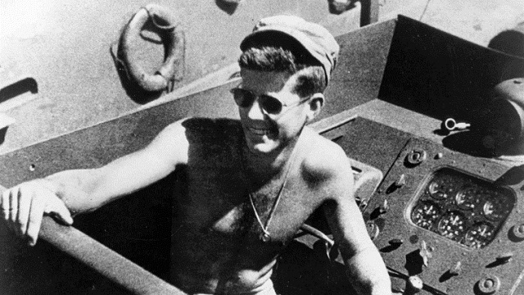

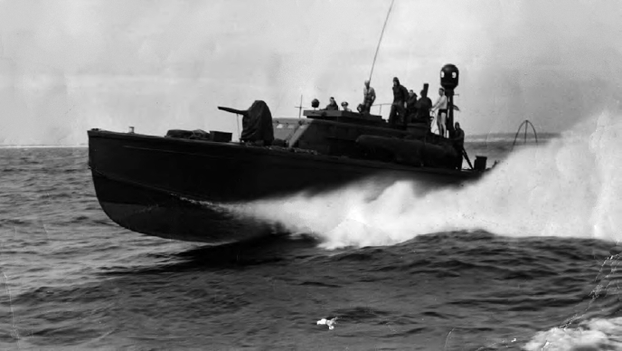

WHEN; ON THE CAMPAIGN TRAIL; DID YOU RECALL PATROL TORPEDO BOAT 109; AND A YOUNG MAN WHO HAD IT ALL; BUT WOULDN’T TAKE NO FOR AN ANSWER; WHEN HIS BAD BACK DISQUALIFIED HIM; AND HE WAS REJECTED BY NAVY DOCTORS; FOR SERVICE TO AMERICA?

JOHN FITZGERALD KENNEDY THREADED A NEEDLE OF DECEPTION & LIES TO CON HIS WAY INTO THE NAVY. HE BECAME COMMANDER, ON MERIT ONLY; OF PATROL TORPEDO BOAT 109 - - MOTTO “THEY WERE EXPENDABLE.” HIS (56) TON CRAFT HAD A CREW OF (14) & CARRIED (4); 3150 LB. MARK 8 TORPEDOES; A 20 MM CANNON; (4) 50 CALIBER MACHINE GUNS & A 37 MM ANTI-TANK GUN. WHY NOT EXPLAIN YOUR PRESIDENCY AS A PROFILE IN COURAGE; IN WINNING FOR US; AGAINST ALL ODDS?

THE ODDS WERE; DESPITE HIS BAD BACK; TOWING CRITICALLY BURNED SENIOR ENLISTED MACHINIST’S MATE MM1 PATRICK MCMAHON 3.5 MILES TO THE DESERTED PLUM PUDDING ISLAND; WITH MCMAHON’S LIFE PRESERVER STRAP CLENCHED BETWEEN HIS TEETH, THROUGH CROCODILE & SHARK INFESTED WATERS. GOOGLE IT. IT’S TRUE.

PATROL TORPEDO BOAT 109 HAD BEEN CUT IN HALF; AND HAD EXPLODED IN FLAMES; AUGUST 2, 1943; AFTER BEING RAMMED AT 40 KNOTS; 46 MPH; BY JAPANESE DESTROYER AMAGIRI. BY ACCIDENT; AMAGARI HAD STUMBLED UPON PT 109; IDLING ON ONE ENGINE. FROM A MILE AWAY; AMAGARI FLOORED IT. DO YOUR BUDDY RANDI WEINGARTEN’S TEACHERS; EVER TEACH ABOUT AMERICAN EXCEPTIONALISM, ANYMORE?

DO YOUR BUDDY RANDI’S TEACHERS EXPLAIN WHY, TO KIDS; A BOOT TURNED BACKWARDS & UP IN THE STIRRUP OF A RIDERLESS HORSE SHOULD MEAN SOMETHING TO THEM? THEY’D LOVE A LESSON, OR AN ENTIRE SCHOOL YEAR BUILT OF THAT.

I DARE YOU TO TEACH THIS LESSON, AMERICAN FEDERATION OF TEACHERS PRESIDENT, RANDI WEINGARTEN. I DOUBLE DARE YOU.

WE NEVER EXPECTED THIS HEROISM FROM EVITA. ALL WE WANTED; WAS FOR HER TO AT LEAST ACKNOWLEDGE THE GREAT AMERICAN EXCEPTIONALISM OF DEMOCRATIC PRESIDENTS PAST; AND TO PROMISE AMERICA THAT SHE’D LOOK BACK IN HISTORY; FOR HER OWN CUES FOR LEADERSHIP; FROM GREAT DEMOCRATIC PARTY PROFILES IN CHARACTER, LOVE FOR AMERICA & COURAGE.

HILLARY RODHAM CLINTON HAD TO ONLY TO PROMISE US THAT SHE’D BE OUR PRESIDENT EVERY BREATHING MOMENT; AS IF DEMOCRATS FDR; “GIVE ‘EM HELL” HARRY; AND JFK WERE LOOKING DOWN ON HER.

THAT’S ALL WE EVER WANTED FROM HILLARY.

NOTHING LESS.

NOTHING MORE.

WE WANTED HER TO BE THE PRESIDENT THAT ABRAHAM LINCOLN; AND A YOUNG ALEXANDER WHO ONCE MADE THE GROUND SHAKE BENEATH 500,000 WEST GERMANS; WANTED HER TO BE.

AS FROM HIM; “ICH BIN EIN BERLINER,” JUNE 26, 1963; WE WANTED THE SAME FROM YOU.

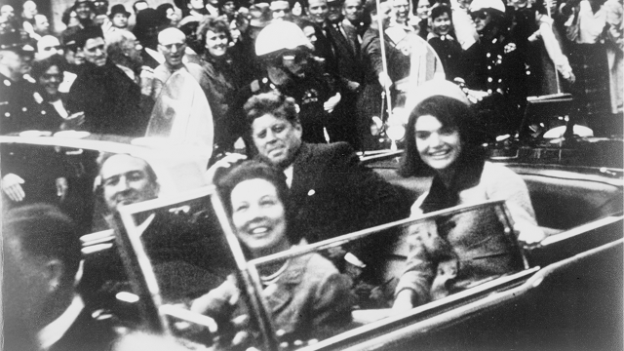

HE HAD WIT, STYLE & FLAIR TO SPARE; AS NEVER BEFORE, OR EVER AGAIN.

“I’LL ALWAYS BE REMEMBERED AS THE MAN WHO ACCOMPANIED JACQUELINE KENNEDY TO PARIS.”

THOSE WHO HATED US CHEERED; LAUGHED UNTIL THEY CRIED; & CHEERED & LAUGHED UNTIL THEY CRIED AGAIN. HILLARY’S MY AGE. SHE WAS THERE. SHE KNOWS IT. WHY COULDN’T SHE JUST ANCHOR HER CAMPAIGN INTO THE HEART & SOUL OF THE BEST OF THE GREAT AMERICA LOVING DEMOCRATIC PARTY PAST; AND IT WAS GREAT; INSTEAD OF HER CONTRIVED; FORMULAIC & SHALLOW “I’M NOT DONALD J. TRUMP.” HILLARY’S “ELEVEN HERBS & SPICES” WERE JUST WAITING FOR HER, THERE FOR THE TAKING.

SEEKING EXPOSURE TO THE PEOPLE OF TEXAS; HE DECLINED THE BULLETPROOF; REMOVEABLE MIDNIGHT BLUE LINCOLN CONTINENTAL CONVERTIBLE; PROTECTIVE BUBBLE; LEFT IN THE AIR FORCE 1 CARGO HOLD. LOOKING TO 1964; KENNEDY HAD WON TEXAS’ (24) ELECTORAL VOTES IN 1960 BY 45,257 VOTES; 1,167,567: 1,121,310. HE WAS WARNED TO USE HIS BULLETPROOF BUBBLE. KENNEDY SPUN THE ROULETTE WHEEL. HE CAME UP SHORT.

FROM THE 6TH FLOOR TEXAS BOOK DEPOSITORY WINDOW, (90) YARDS AWAY; THE SAME MODEL 91/38 FUCILE DI FANTERIA BULLET WENT THROUGH KENNEDY’S SKULL AND TEXAS GOVERNOR JOHN CONNALLY’S THIGH. THE 2ND HAND; $19; MAIL ORDER WEAPON; INTRODUCED IN 1891; WAS MANUFACTURED IN AXIS WARTIME ITALY IN 1940; AT THE TERNI; ITALY ROYAL ARMS FACTORY.

THE 1964 PRESIDENTIAL ELECTION WAS WON IN A LANDSLIDE OVER BARRY GOLDWATER BY JOHN FITZGERALD KENNEDY’S VICE PRESIDENT LYNDON BAINES JOHNSON OF TEXAS; WHERE JOHN FITZGERALD KENNEDY WAS MURDERED. IN 1960; WHEN ASKED WHY HE CHOSE LYNDON BAINES JOHNSON OF TEXAS AS HIS RUNNING MATE; OBVIOUSLY WANTING TEXAS’ (24) ELECTORAL VOTES; THE (43) YEAR OLD CANDIDATE SAID; “BECAUSE I WANT TO WIN.”

FROM 1915 - - EDGAR LEE MASTERS:

“OF OTHER DAYS OF OTHER MEN;”

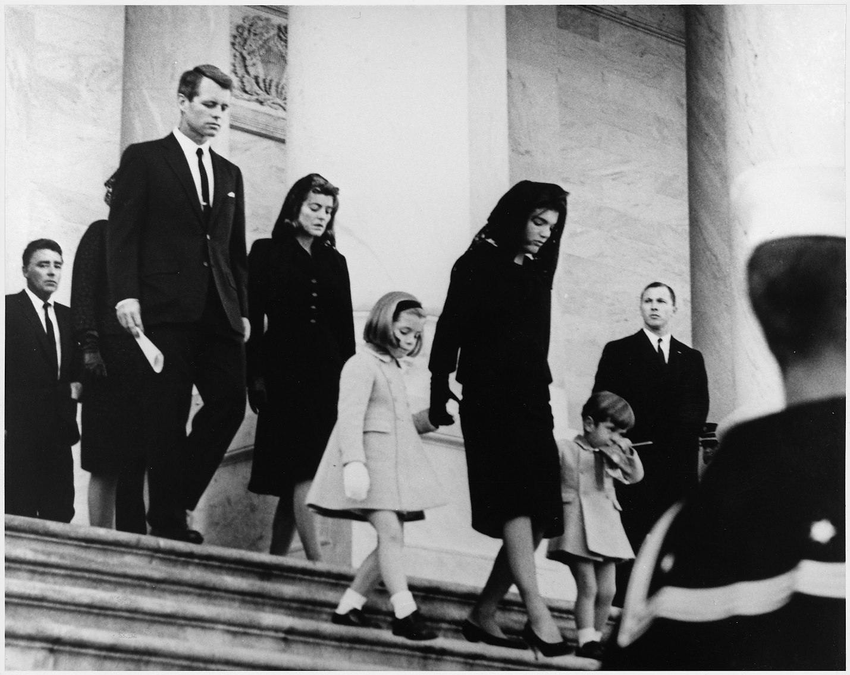

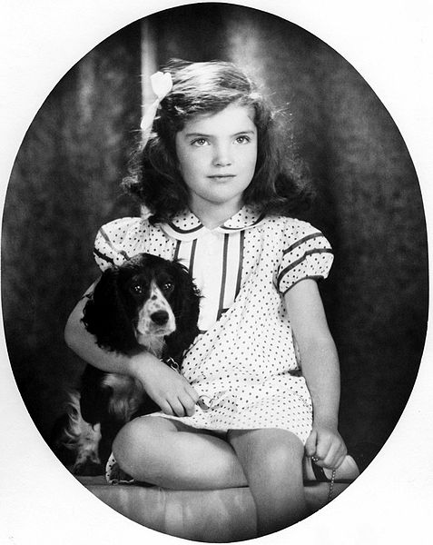

JACQUELINE BOUVIER KENNEDY, AGE SIX

“THERE’S NO GOING BACK; THERE’S ONLY THE YEARN”

WE HAD ROMANCE & LEGEND. HAVEN’T WE HUNGERED FOR, & THIRSTED FOR THE BOOMERANG OF IT; TO COME BACK TO US AGAIN?

ON A CLEAR DALLAS NOVEMBER DAY; (88) DAYS AFTER “ICH BIN EIN BERLINER;” WE COULD SEE FOREVER.

WE KNEW WHO, WE WERE.

ON THAT CLEAR DAY;

HOW IT WOULD ASTOUND US ….

THAT A TORCH IN A HARBOR, OUTSHINED EVERY STAR …

WE WERE PART OF; EVERY MOUNTAIN SEA & SHORE;

WE COULD HEAR; FROM FAR & NEAR

THAT GOD WOULD BRING US EVEN MORE

ON A CLEAR DAY …

ON THAT CLEAR DAY …

WE COULD SEE FOREVER …

AND WE KNEW WHO,

WE WERE …

TRIOLETS; VILLANELS; RONDOS; ROUNDELLS;
BALLADS BY THE SCORE, WITH THE SAME OLD THOUGHT …
THE SNOWS IN THE ROSES OF YESTERDAY ARE VANISHED
AND WHAT IS CHARITY FOR ALL …
AND MALICE TOWARDS NONE;
BUT A ROSE THAT FADES …

LIFE, ALL AROUND US, IN AMERICA
TRAGEDY, COMEDY, VALOR & TRUTH
COURAGE, CONSTANCY, HEROISM, FAILURE
ALL IN THE LOOM;

AND OH, WHAT PATTERNS;
WOODLANDS, MEADOWS,
STREAMS & RIVERS
MANIFEST DESTINY

IT WAS ONLY …
ALWAYS THREE GIANT STEPS BACKWARD
FOR EVERY ONE BABY STEP FORWARD
THAT’S ALL WE EVER WANTED FROM HILLARY …
JUST HER BEST EFFORT …
IF SHE GAVE IT;
6.6 BILLION WOULD FORGIVE HILLARY’S HONEST MISTAKES …

HIS KINGDOM COME
HIS WILL BE DONE;
IN AMERICA;
AS IT IS IN HEAVEN

- OUR OWN MAGICAL CAMELOT;
- OUR MAGICAL PRINCE & PRINCESS;
- OUR OWN SPECIAL KIND OF BEAUTY …

OUR OWN LITTLE BIT OF GLORY;

A BLUR BEFORE PARKLAND HOSPITAL …

ASK EVERY PERSON IF HE KNOWS THE STORY

AND TELL IT STRONG & CLEAR IF HE DOES NOT …

THAT ONCE WE HAD A FLEETING WISP OF GLORY …

DON’T EVER, EVER, LET IT BE FORGOT
THAT ONCE THERE WAS A SPOT
OUR SHINING MOMENT
OF SIRENS SCREAMING …
THINK BACK ON ALL THE TALES THAT YOU REMEMBER
LET ALL YOUR CHILDREN’S CHILDREN
TELL OUR STORY
DON’T EVER, EVER, LET IT BE FORGOT
LET EVERY CHILD’S EAR
OUR PRECIOUS STORY HEAR

THAT ONCE WE HAD OUR LITTLE BIT OF GLORY
A FLEETING SPECIAL ONCE UPON A STORY
THEY CALLED THEIR DAUGHTER’S PONY MACARONI …
IT BECOMES SO VERY, VERY LONG AGO …
PLEASE;
DON’T EVER, EVER, LET OUR LEGEND GO

HE VANISHED LONG AGO IN SIRENS SCREAMING

OUR FAIREST, FAIREST WIDOW OF THEM ALL …

SHE SAID:

“NOT EVERY MAN CAN BE GREAT …
BUT EVERY MAN SHOULD TRY …”

SHE COULDN’T BEAR KEEPING THE PORTRAIT OF HER HUSBAND THAT SHE RETURNED TO ROBERT MCNAMARA AFTER ONE DAY. THE PORTRAIT WAS PROPPED UP AGAINST HER BEDROOM DOOR; JUST DAYS AFTER HER HUSBAND WAS MURDERED …

THREE YEAR OLD JOHN JUNIOR CAME OUT OF MOM’S BEDROOM.

HE TOOK A YELLOW LOLLIPOP OUT OF HIS MOUTH

HE KISSED THE PORTRAIT OF DAD …

“GOODNIGHT DADDY;” HE SAID.

AT THE FUNERAL; SHE HELD AMERICA TOGETHER. SHE WAS OUR SYMBOL OF RESOLUTE DIGNITY. COURAGE, COMPOSURE, & STRENGTH.
SHE NEVER CRIED IN FRONT OF US.

NEVER.

NOT ONCE.

SHE WON NO OSCAR.

SHE CRIED ALONE.

SHE IS OUR STORY.

WHY COULDN’T HILLARY JUST HAVE MADE A BEST PRACTICES, BEST HEARTFELT EFFORT, TO ONLY GRAB THE BATON FROM WHERE ANOTHER FIRST LADY, JACKIE, LEFT OFF?

WHY COULDN’T SHE?

WHY NOT?

WHY COULDN’T SHE AT LEAST EVEN TRY?

WHY DIDN’T SHE EVEN THINK OF IT?

WHY NOT?

WAS JACKIE’S BAR TOO HIGH?

IN WONDERMENT, WE WATCHED JACKIE’S 1961 SUNDAY NIGHT ONE HOUR SPECIAL; HER TELEVISED TOUR OF THE WHITE HOUSE. OUR IMPOSSIBLE DREAM GIRL WAS NOT ONLY THE PRIZE COVER OF VOGUE; SHE ALSO, ACTUALLY CLIPPED COUPONS TO SAVE MONEY, WHILE SHE WAS OUR FIRST LADY IN THE WHITE HOUSE. WE WERE MESMERIZED.

WE WERE IN LOVE WITH HER. WE WERE IN LOVE WITH THEM. IT COULDN’T BE HAPPENING. IT WAS TOO GOOD. THEY WROTE ABOUT THIS IN MAGAZINES. ROBERT KENNEDY, WHO FELL TO SIRHAN SIRHAN’S BULLET TO HIS HEAD, JUNE 5TH, 1968, SHORTLY AFTER MIDNIGHT IN THE KITCHEN OF THE LOS ANGELES AMBASSADOR HOTEL, THE SAME NIGHT HE WON THE CALIFORNIA PRESIDENTIAL PRIMARY; SAID WHEN HIS BIG BROTHER DIED, “THINGS WERE GOING SO GOOD.”

NAVY LIEUTENANT JOSEPH P. KENNEDY JR.; ON A TOP SECRET EXPERIMENTAL; ROBOTIC; B-17 OPERATION APHRODITE, AUGUST 12, 1944, WAS SHOT DOWN & KILLED AT AGE 29; IN THE MOST DANGEROUS U.S. MILITARY, AIR MISSION IN HISTORY.

PINCH HITTING FOR HIS BIG BROTHER; WHO WAS DESTINED TO REPRESENT THE FAMILY IN THE WHITE HOUSE, JFK LASTED A THOUSAND DAYS.

“JOHNNY, WE HARDLY KNEW YE.”

MY FATHER ALWAYS QUOTED THE 35TH PRESIDENT OF THE UNITED STATES. “LIFE IS UNFAIR.”

JACKIE BECAME THE DEMOCRATIC PARTY.

JACKIE WILL ALWAYS BE THE DEMOCRATIC PARTY.

JACKIE WILL ALWAYS BE OUR WOMAN CARD.

JACKIE WAS TORTURED BY WHAT SHE COULD’VE DONE DIFFERENTLY TO HAVE SAVED HER HUSBAND; TURNING TO THE RIGHT AT THE LAST INSTANT; UP TO & INCLUDING HOLDING HIS BRAINS; WITH HER HANDS; INTO HIS SKULL.

WITH SQUAD CAR LIGHTS FLASHING & SIRENS SCREAMING; THE 1961, MIDNIGHT BLUE LINCOLN CONVERTIBLE LIMOUSINE WITH JUMP SEATS; CLOCKED 115 RACING THROUGH DALLAS CITY STREETS TO TRAUMA AT PARKLAND HOSPITAL. JFK ACTUALLY SAID WHEN THE BULLET HIT, “I’VE BEEN KILLED.”

JACKIE CONNECTED THE LOSS OF HER HUSBAND TO THE LOSS OF HER TWO BABIES; STILLBORN ARABELLA IN 1956; & PATRICK BOUVIER KENNEDY; WHO DIED AT TWO DAYS OLD; FEWER THAN 100 DAYS BEFORE HIS DAD WAS MURDERED.

TWO WEEKS AFTER THE PRESIDENT WAS BURIED; JACKIE BROUGHT DOWN THE CURTAIN OF CAMELOT; BY UNITING, NOT IN LIFE, BUT IN DEATH; HER TWO LOST INFANTS FROM HOLYOKE CEMETERY IN BROOKLINE, MASSACHUSETTS; TO BE WITH THEIR DAD.

BISHOP PHILIP HANNA HAD GIVEN THE EULOGY FOR PRESIDENT JOHN FITZGERALD KENNEDY AT ST. MATTHEWS CATHEDRAL.

JACKIE; BOBBY KENNEDY; HER MOTHER; JANET AUCHINCLOSS; JACKIE’S SISTER; LEE RADZIWILL AND A FEW OTHERS GATHERED IN THE DECEMBER CHILL; WITH JACKIE; AS THE CLOCK STRUCK MIDNIGHT; BESIDE THE ETERNAL FLAME AT ARLINGTON NATIONAL CEMETERY; TO RE-INTER ARABELLA & PATRICK, TO BE WITH THEIR DAD. JACKIE AND BISHOP HANNAN EACH LAY A HEARTBREAKINGLY SMALL WHITE CASKET; ONE EACH CONTAINING ARABELLA & PATRICK; ON THE FROST BESIDES HER HUSBAND’S FRESHLY DUG GRAVE. BISHOP HANNAN RECITED A SHORT PRAYER. JACKIE SIGHED DEEPLY & AUDIBLY.

“THE HEARTBEAT OF AMERICA” 1985 – 1993, WAS CHEVROLET’S 3RD MOST MEMORABLE ADVERTISING CAMPAIGN.

THE 1963 FLICKERING, FLEETING WISP, “HEARTBREAK OF AMERICA, FLAME OF CAMELOT; RIPPED HEARTS FROM THE DEPTHS OF OUR HEARTSTRING MOORINGS; IN THE BERMUDA TRIANGLES OF OUR TWILIGHT ZONES.

JOHN FITZGERALD KENNEDY TORE UP WHAT WAS LEFT OF HIS CONGENITAL BAD BACK, WHEN HE TOWED CRITICALLY BURNED MACHINIST MATE PATRICK MCMAHON, FROM THE FLAMING WRECK OF HIS PT 109; THREE & A HALF MILES, TO PLUM PUDDING ISLAND; BY THE STRAP OF MCMAHON’S LIFE JACKET; CLENCHED IN HIS TEETH.

WE ALL KNEW OF THE WOODEN BOSTON ROCKER THAT OCCASIONALLY RELIEVED JFK’S BACK PAIN. TO RELIEVE HIS PAIN, HE DID MUCH OF HIS WHITE HOUSE WORK STANDING UP.

THE HAUNTING PHOTO OF HIS ROCKER BEING CARRIED FROM THE WHITE HOUSE TO THE MOVING TRUCK, WAS UNBEARABLE.

FEW KNEW THE BITTERSWEETNESS OF JACKIE’S LEANING ON HER BLUEBLOOD, PATRICIAN, WHITE HOUSE CHIEF OF PROTOCOL; ANGIER BIDDLE DUKE.

JACKIE’S FATHER, JOHN VERNOU “BLACK JACK” BOUVIER III, SUCKED INTO THE 1929 STOCK MARKET BLACK HOLE; BECAME A PHILANDERING ALCOHOLIC, THE YEAR JACKIE WAS BORN.

ATTENDING GRADES 1 – 6 AT MANHATTAN’S CHAPIN PRIVATE SCHOOL, STILL THERE AT 100 EAST END AVENUE; LITTLE MISS PERFECT WAS A CHRONIC, ADORABLE, MISBEHAVING LITTLE BRAT. GIRLS LIKE HER ARE EVEN MORE ADORABLE WHEN THEY’RE BAD, AND SNEAKINGLY TRYING TO GET AWAY WITH SOMETHING, WITHOUT GETTING CAUGHT. THIS MADE HER EVEN MORE SCRUMPTIOUS. A TEACHER CALLED HER “THE PRETTIEST LITTLE DARLING CHILD, FULL OF THE DEVIL; VERY CLEVER AND VERY ARTISTIC.

OUR GIRL-CHILD FIRST LADY LEANED ON HER “BEEN THERE, DONE THAT,” ARISTOCRATIC WHITE HOUSE PATRICIAN CHIEF OF PROTOCOL; ANGIER BIDDLE DUKE. WHEN BRITAIN’S QUEEN ELIZABETH VISITED THE CAMELOT WHITE HOUSE FOR THE FIRST TIME; PRETTY; PRIM; PROPER & PERFECT MISS JACKIE ENTREATED GUIDANCE FROM HER BIG BROTHER BIDDLE ON “THE STATE OF THE ETIQUETTE” PROPRIETY IN WELCOMING THE DEFINING (37) YEAR OLD ROYALTY.

ALICE IN WONDERLAND:

“SHOULD I CURTSEY THE FIRST TIME I WELCOME THE QUEEN TO THE WHITE HOUSE?” “ABSOLUTELY NOT,” CORRECTED BIDDLE. “JACKIE, YOU’RE THE FIRST LADY OF THE UNITED STATES, EQUAL TO; BUT ACTUALLY; ABOVE THE STATURE OF ANYONE, INCLUDING THE QUEEN OF ENGLAND. FOR YOU TO CURTSEY WOULD SHOW YOU AS A SUPPLICANT; WITH THE QUEEN IN RANK ABOVE YOU. IT IS YOUR HUSBAND; WHO IS THE MOST POWERFUL; HIGHEST RANKING MAN IN THE WORLD.”

ALL OF THE WORLD’S LEADERS ATTENDED HER HUSBAND’S MONDAY, NOVEMBER 25, FUNERAL. ON THE RECEIVING LINE TO GREET ALL LEADERS, FOLLOWING THE ARLINGTON NATIONAL CEMETERY BURIAL OF HER HUSBAND, QUEEN ELIZABETH APPROACHED JACKIE.

IN DEFERENCE TO QUEEN ELIZABETH, JACKIE CURTSEYED.

NEXT TO HER ON THE RECEIVING LINE, BIDDLE SOFTLY CHIDED JACKIE. DIDN’T I EXPLAIN TO YOU ABOUT CURTSEYING WITH RESPECT TO QUEEN ELIZABETH?

LIKE A SLINGSHOT; FIRST BRAT SHOT BACK:

“BUT I’M NOT FIRST LADY ANYMORE.”

(3) HOURS AFTER THE MURDER, LADY BIRD JOHNSON BECAME FIRST LADY. ON AIR FORCE 1, CAMELOT BECAME A BRONZE COFFIN. HAND ON A BIBLE, A HEARTBEAT AWAY, THE 36TH PRESIDENT; LYNDON BAINES JOHNSON, WAS IN THE SKY.

THE SUNDAY AFTER THE FUNERAL; THE NEW YORK GIANTS PLAYED THE DALLAS COWBOYS WHERE CAMELOT ENDED, AT THE COTTON BOWL IN DALLAS. THE GIANTS WON, 34-27; IN AN 11-3 SEASON, AND LOST 14–10; IN THE NFL CHAMPIONSHIP GAME. THE 1963 DALLAS COWBOYS FINISHED 4– 10; 5TH IN THE EASTERN CONFERENCE.

AFTER THE FUNERAL; THREE DAYS LATER, AMERICA’S TABLES GROANED BENEATH TURKEYS, FROM SEA TO SHINING SEA.

JACKIE’S THANKS, IF ANY, THAT THANKSGIVING DAY; ARE PROVENCE ONLY TO GOD. JOHN JR.’S BIRTHDAY WAS THE DAY SHE LOST HER HUSBAND. FOR JOHN JR.’S DELAYED 3RD BIRTHDAY PARTY, AMON RA THROUGH ZEUS, STOPPED TIME TO ATTEND. VENUS, JESUS OF NAZARETH, THE SUN GOD, AMON RA, ZEUS, VULCAN, MARS, APHRODITE, MERCURY & JUPITER, SHANGO, SHIVA, VISHNU & DEVI, SILVER FOX, BUDDHA, CONFUCIUS; ALLAH, JEHOVAH & JOHN PAUL II, EVEN VOODOO QUEENS, WICCA & PLUTO, ALL CRIED A RIVER UPON US; UNTO ETERNITY, WITH HOLES IN THEIR HEARTS, ALL MOURN, IN TEMPLES, REDUCED TO SAND, TILL LONG PAST THE END OF TIME.

A MIRAGE, IN AN ENGLISH SADDLE

WITH JACKIE, GOD GOT LUCKY …

ONE, SINGULAR SENSATION;
EVERY LITTLE BREATH SHE TAKES
ONE, THRILLING COMBINATION,
EVERY LITTLE MOVE THAT SHE MAKES
ONE SMILE AND SUDDENLY,
NOBODY ELSE, WILL DO …
NO SPELL CELESTIAL
EVER, LIKE YOU, KNOW WHO …

WHY DID BIRDS, SUDDENLY APPEAR …
EVERY TIME, SHE WAS NEAR
JUST LIKE US, THEY LONGED TO BE
CLOSE TO HER
WHY WOULD STARS,
FALL DOWN FROM THE SKY …
EVERY TIME, SHE WALKED BY?
ON THE DAY THAT SHE WAS BORN
THE ANGELS GOT TOGETHER
AND DECIDED TO CREATE A DREAM COME TRUE
OF AMBER WAVES OF GRAIN
TO CROWN, OUR HOOD,
WITH WOMANHOOD …

I JUST RAN OUT OF WORDS.

YOU PICK UP, WHERE I LEFT OFF.

AFTER JACKIE, GOD THREW AWAY THE MOLD.

WE LAUGHED WITH HER.

WE ADMIRED HER.

WE ARE PROUD OF HER.

SHE MADE US PROUD TO BE AN AMERICAN.

WE LOVED THEM.

WE CRY FOR HER.

JACQUELINE BOUVIER KENNEDY; (JULY 28, 1929 – MAY 19, 1994); IS EVERLASTING IN THE HEARTS OF HER COUNTRYMEN. MAY THE LEGEND OF CAMELOT NEVER DIE; BUT FOREVER GROW.

SHE IS OURS.

“ONCE, THERE WAS A LITTLE BIT OF GLORY.”

HILLARY, WHY COULDN’T YOU JUST SAY IT?

WHY COULDN’T YOU JUST PROMISE TO TRY TO BRING IT BACK?

WHY COULDN’T YOU JUST PROMISE TO AT LEAST TRY?

THAT’S ALL WE EVER WANTED FROM YOU.

THERE WILL ALWAYS BE AN AMERICA.

JACKIE SAID:

“THERE’LL BE OTHER GREAT PRESIDENTS …”

“BUT THERE WILL NEVER BE ANOTHER CAMELOT. “
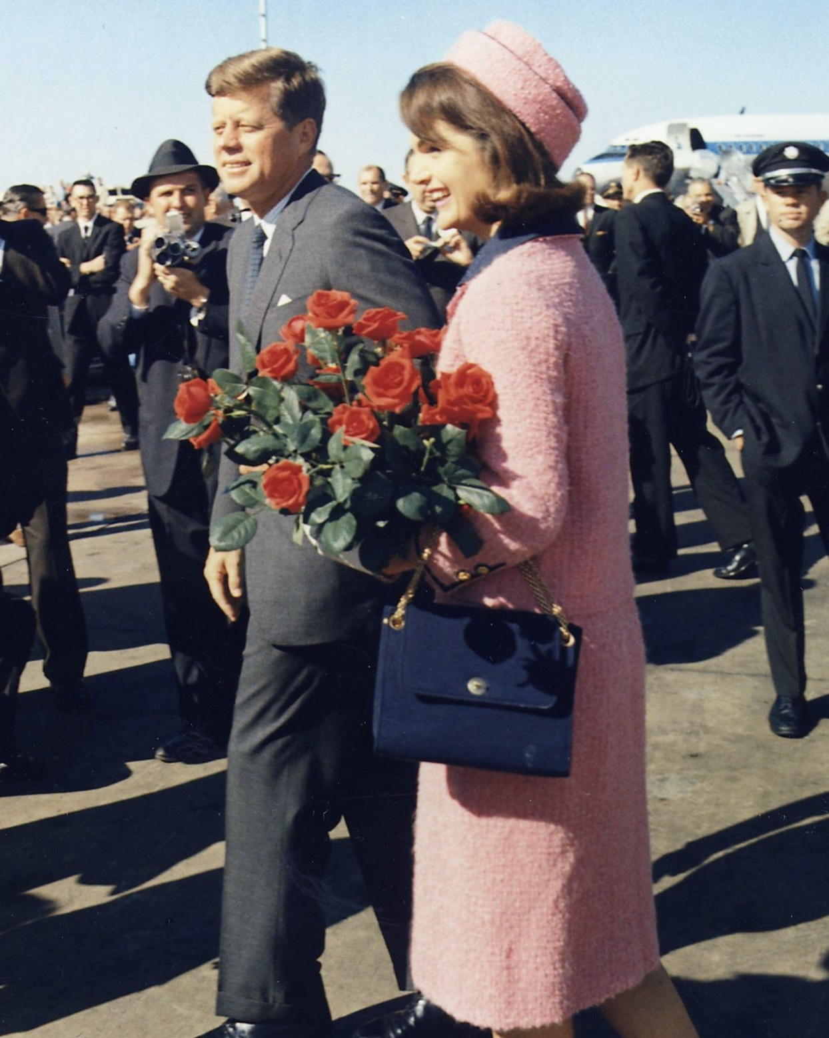
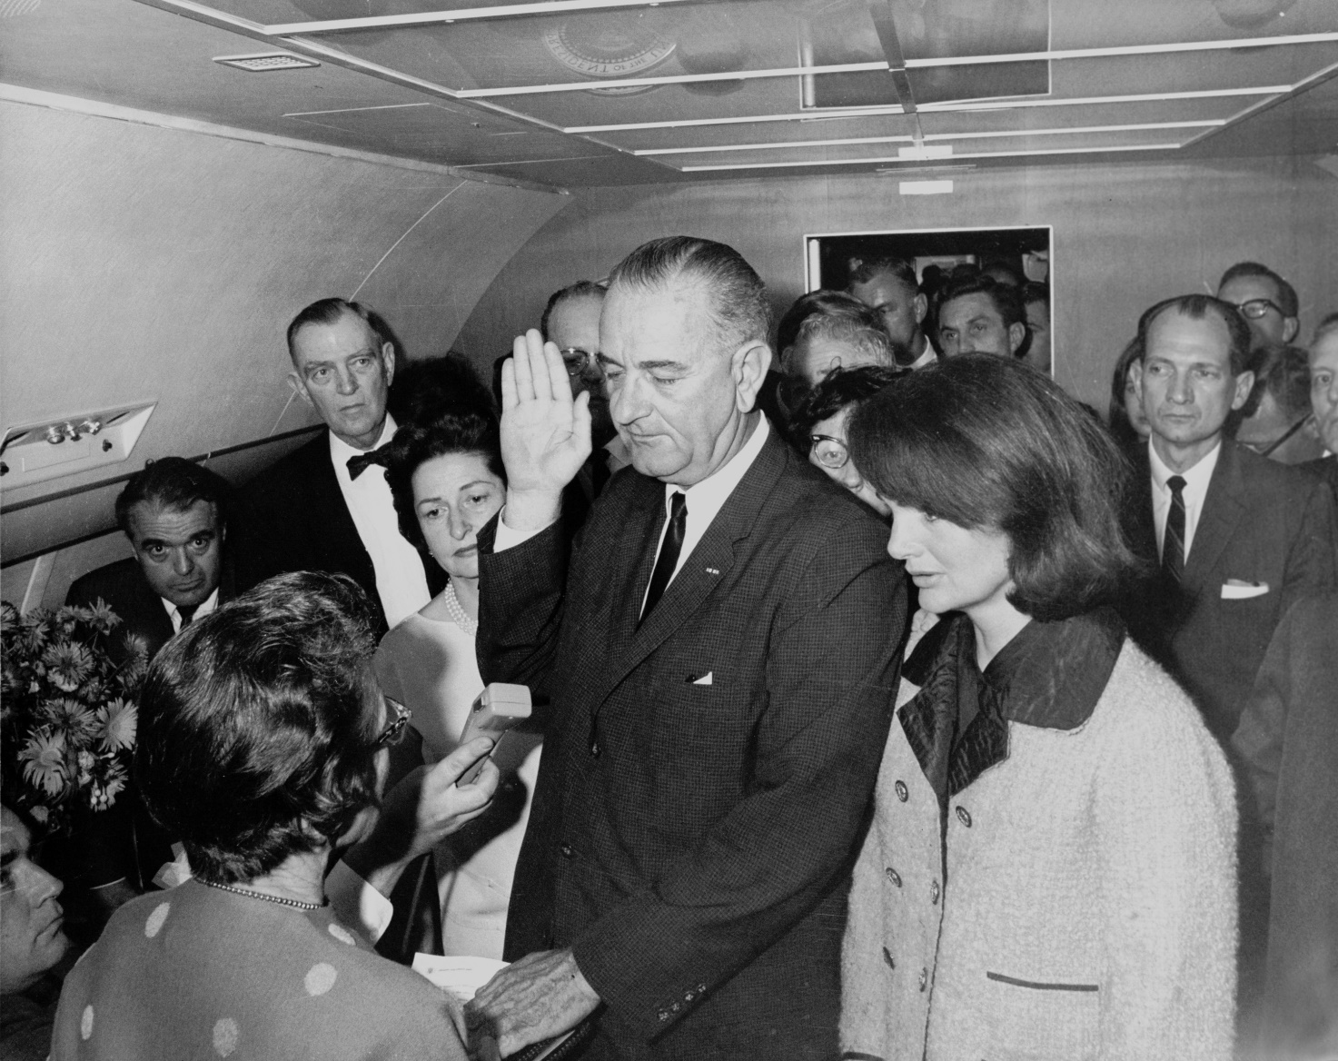

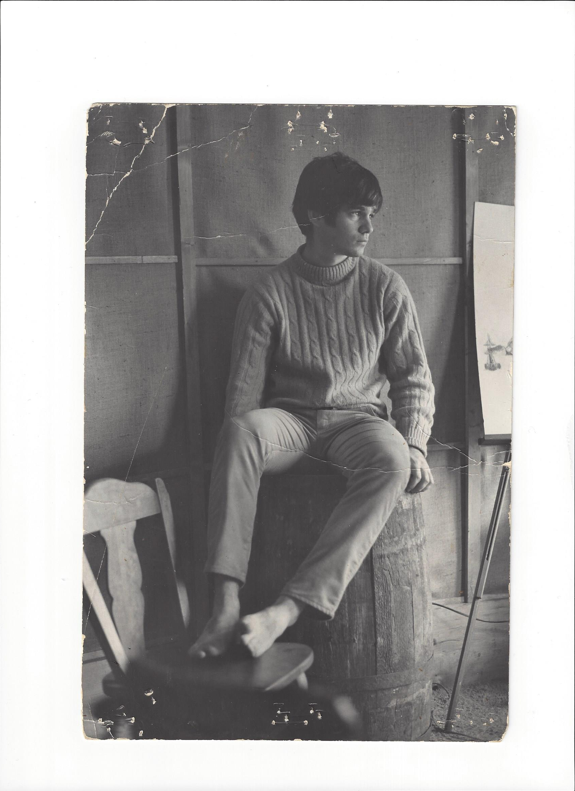

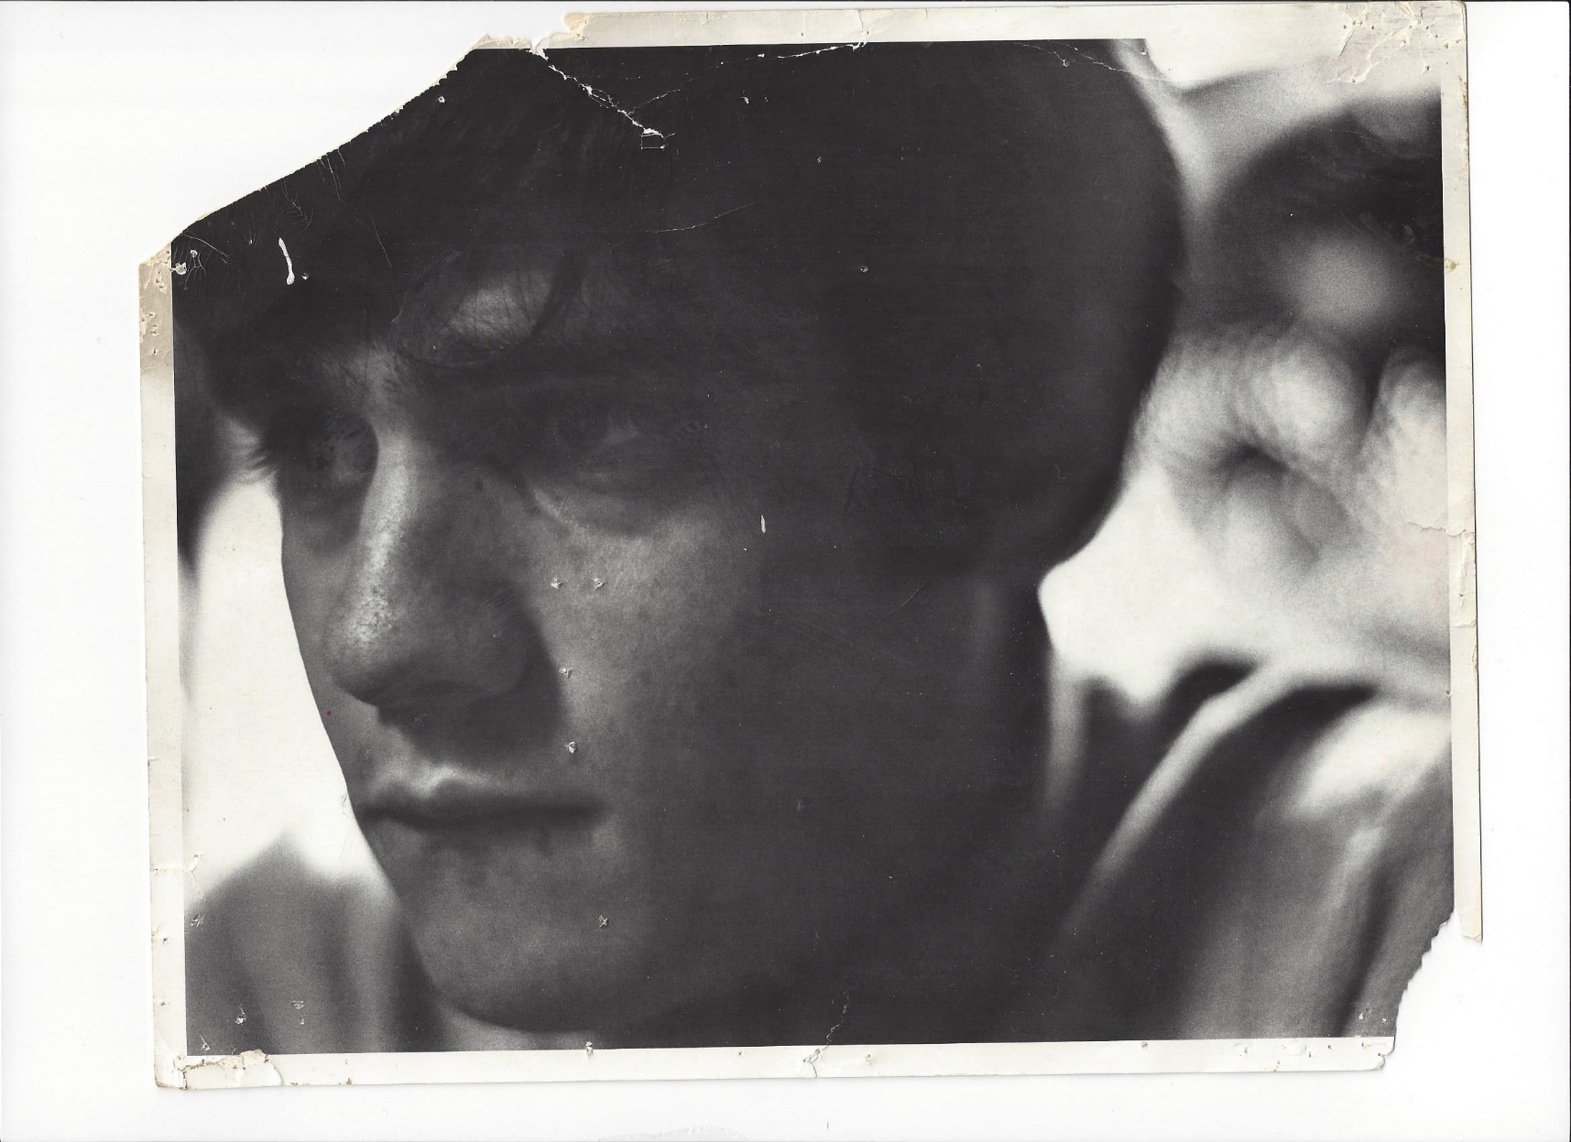


SERENA was the dog; KARENNA was the girl; from which dreams were born; and time was never planned. We dreamt of lovely things; we had hearts that flew on wings; to NEVER, NEVER LAND. We had a treasure because we’d got there; more precious far than gold. And because we had finally gotten there; we would never, ever grow old.

KARENNA was my HOPE DIAMOND that I’d stumbled on from a box of CRACKER JACKS. We lay on the twin bed in her bedroom watching the CAROL BURNETT SHOW. Her beautiful eyes implored me. “All I ever wanted was a loving husband to come home to and watch TV with.”

“I want to be married.”

“To you.”

I never bought KARENNA the plastic ring in the plastic capsule from the vending machine at WOOLWORTHS. I didn’t have to. She was my very own AUDREY HEPBURN; my very own HOLLY GOLIGHTLY.

She embraced me on a MIDSUMMERS’ NIGHT’S dreamscape; in drenching rain; after we’d found her cat; that had run away.

I’ve already been to HEAVEN. KARENNA took me there.

She turned away rich kids from GREENWICH; with daddy’s garaged LINCOLN on demand; their own TRIUMPH; cute little MG; MUSTANG; GTO or LOTUS; guys with fathers in PARK AVENUE corner offices; running WHITE GLOVE WALL STREET LAW FIRMS and BANKS chased KARENNA. They had the pockets of the HUGHES’ and the ROCKEFELLERS; for BAUBLES; BANGLES and BEADS at TIFFANY’S; lavish spreads at reserved tables at 21; EL MOROCCO; LA BRASSERIE and the FOUR SEASONS; vacations in MARTINIQUE; private jets; an allowance for KARENNA’S rent; and a credit card for their first choice TROPHY GIRLFRIEND.

All KARENNA ever wanted; from the instant her eyes first met mine; from our rear bedroom sixth floor facing windows; was the poor JEWISH boy who’d bounced through two broken homes; snaking through a dozen relative and foster home environments by age six. I never spent a penny on KARENNA. I didn’t have to. KARENNA never wanted anything from me; except for me to be hers; and hers alone, till death do us part.

I was the only act in KARENNA’S three ring circus; under her big top.

She asked me once. Do you like me being beautiful?

Once, all 5’4”; 122 lbs. of her announced to me; “I want you to watch me taking a bath.”

She soaped herself with AMARETTO; foaming; glistening bubbles; my shimmering; glimmering; PRINCESS GODDESS, VENUS APHRODITE. I wrapped & massaged KARENNA in a great, white terrycloth bath towel.

In her bedroom; that night and every other; KARENNA was more of a wild animal than a human being; self-assured of her magnetic desirability; like no other peer; like no other girl. Only a battle hardened; hopefully a NAVY SEAL; could survive her bedroom assaults. It wasn’t a forgone conclusion I’d live; with no possibility of escape. A ten year LAS VEGAS SIEGFRIED & ROY WHITE TIGER APPRENTICESHIP would have helped. A RINGLING BROTHERS; BARNUM & BAILEY; under the BIG TOP; GREATEST SHOW ON EARTH center ring; MASTER CERTIFICATION as a FLAMING HOOP TAMER & TRAINER of
GIANT CAT HUNTERS OF THE JUNGLE; would’ve been better. I had to be ready for anything; maybe the dying flick of MOBY DICK’S tail; that HERMAN MELVILLE used to kill QUEEQUEG.

KARENNA said it so beautifully, touchingly, hauntingly; preciously; as never said by another girl; to another man.

She would have paid; begged; borrowed or stole five dollars for our marriage license.

She said “WE’RE A PAIR.”

I wanted KARENNA twice as much as she could ever want me. I turned my PARADISE POSSIBLE, into PARADISE LOST.

The impossible went wrong; in our happily ever after; second chance, dream-come-true SHANGRI-LA PROMISED LAND; twice, forty seven years apart.

All we ever wanted & needed; was what we had with each other; till death do us part; telescoped into hatred of her POLITICS; SOCIAL CONTRACT; CLIMATE; MILITANT FEMINISM; CASTRATION OF AMERICAN EXCEPTIONALISM; ALPHA MALES; a powerful MILITARY; ANTI-CAPITALISM; RACIAL DOGMA; 35% GOVERNMENT GDP; assault on CHARTER SCHOOLS; and PRE-SCHOOL THROUGH DOCTORAL HARD-LEFT; STRIDENT; ORTHODOX; DOCTRINAIRE; SECULAR; CODE WORD “PROGRESSIVE” MAFIOSO EDUCATION & POVERTY INDUSTRIAL COMPLEX JOBS CARTEL.

At 23; the PROPHET had two LUTHERAN DOCTORATES. As DIETRICH BONHOEFFER warned GERMANY of lies a sick nation wanted to believe; so too would he warn AMERICA. No matter in what disguise the THIRD REICH; or AMERICAN FEDERATION OF TEACHERS comes; it is the same BLACK MAMBA.

“LOVE TO ME IS YOU – THE BLACK MAMBA;” chronicles the thousand year EDUCATION INDUSTRIAL COMPLEX REICH. Our RICHTER 9 romance; was parallel railroad tracks that never touched. We were rings of SATURN in DIETRICH BONHOEFFER’S “CHEAP GRACE” vs. “COSTLY GRACE;” radio warning to GERMANY; cut-off in mid-sentence; by ADOLF HITLER’S jackbooted thugs.

In AMERICA today; as in GERMANY in 1933; DIETRICH BONHOEFFER’S ADMONITION is our COMPASS. In ADAM CLAYTON POWELL SR.’S 132 WEST 138TH STREET, HARLEM, ABYSSINIAN BAPTIST CHURCH; STILL STANDING TODAY, WHERE DIETRICH BONHOEFFER TAUGHT SUNDAY SCHOOL TO YOUNG BLACK CHILDREN IN 1930; AFRICAN AMERICAN SPIRITUAL GOSPELS BECAME HIS “CONFESSING CHURCH.”

EVA MOSKOWITZ, PINCH RAN FOR DIETRICH BONHOEFFER, IN 2006.

EVA’S SUCCESS ACADEMY “STEAL OF HOME” SUCCEEDED; WHERE LYNDON BAINES JOHNSON’S $22 TRILLION WAR ON POVERTY; FAILED MISERABLY; OVER (53) YEARS.

4 FEBRUARY 1906 -
9 APRIL, 1945

BONHOEFFER’S THREE SENTENCES DWARF EVERY HOLY FATHER; MESSIAH; PROPHET AND SAINT COMBINED.

“NOT TO SPEAK, IS TO SPEAK.”

“NOT TO ACT; IS TO ACT”

“SILENCE IN THE FACE OF EVIL, IS EVIL”

EVA SPOKE.

EVA ACTED.

EVA REFUSED TO REMAIN SILENT.

This is why BONHOEFFER was stripped naked in the cold; and strangled to death over six hours. He said no to “DEUTSCHLAND UBER ALLES; DER FUHRER UBER DEUTSCHLAND. DIETRICH BONHOEFFER was the difference; for GERMAN JEWS; between ZYCLON B and SWITZERLAND. “CHRISTIANITY isn’t about CHRIST. CHRISTIANITY is about us; suffering as BONHOEFFER died.”

This is AMERICA, in 2017.

For us it’s not too late.

Soon it will be.

“THE BLOOD OF MARTYRS MIGHT ONCE AGAIN BE DEMANDED.”

Our BLOOD; if we really have the COURAGE and LOYALTY to shed it; will not be INNOCENT; shining like that of the first WITNESSES to our FAITH. In our BLOOD lies HEAVY GUILT; the guilt of the UNPROFITABLE SERVANT; who is cast into OUTER DARKNESS. It is INSUFFICIENT for the CHURCH to BANDAGE the VICTIMS under the WHEEL. We must JAM THE SPOKE of the WHEEL ITSELF.”

Go to Amazon:
Love to Me is You: The Black Mamba
by Richard E. Glick
Link: http://a.co/06Evp0V
Barnes and Noble:
Love to Me is You: The Black Mamba
by Richard E. Glick
Link: http://fw.to/ydMsNoB
To buy this Book

Or go to https://www.buybooksontheweb.com/product.aspx?ISBN=9781495812095
To buy this Book
